# 

# 

Pico Boulevard Safety and Mobility Plan Project

Summer 2025

Social Climate Analysis

The following Social Climate Analysis was developed by Urban Institute with guidance from KDI and input from Fehr & Peers, and reviewed by LADOT.

## **Expected Outcomes of this SCA**

Research shows that engagement practices and public involvement related to transportation and land use have historically prioritized the perspectives of people with higher incomes, white people, and homeowners (Einstein, Glick, and Palmer 2019). However, targeted outreach strategies can help to increase equity in community engagement, such as hosting events in locations that underrepresented communities regularly visit such as recreation centers, schools, or service locations, providing many options for discussion and input, and paying people for their time and providing other supports – such as childcare, language interpretation, and meals – at meetings (Stacy et al. 2022).

To support inclusive engagement efforts, our team conducted a social climate analysis for the Pico Boulevard Safety and Mobility Plan Project using an equity-centered approach. This analysis aimed to deepen understanding of the community’s demographic makeup, lived experiences, and priorities. Our goal was to help shape a culturally responsive and inclusive engagement strategy that centers the voices and values of local residents—especially those who have been historically marginalized in transportation and land use decision-making.

This Social Climate Analysis includes three core components:

* **Demographic and Spatial Data Analysis** – We analyzed a range of indicators including poverty, transportation access, language access, disability status, technology access, age, homeownership status, financial wellbeing, and access to jobs via transportation. We drew on a variety of data sources, including spatial data, to provide a nuanced understanding of community needs and barriers. This analysis is meant to help guide LADOT in tailoring outreach strategies to specific populations and addressing barriers to engagement, and to assess the inclusivity of engagement strategies as they are happening.
* **Community Story Collection** – We conducted interviews and collected stories to capture residents’ lived experiences and perspectives. These stories, presented through quotes, photos, videos, and written responses, offered critical context beyond the data and helped surface values, challenges, and opportunities as expressed by community members themselves. The process also helped identify potential community ambassadors for future engagement.
* **Participatory Planning Activity** – We facilitated a participatory planning activity that brought together community members, LADOT staff, and Council stakeholders to identify concerns related to safety, walkability, and bikeability in the Pico Study Area. This collaborative process generated community-driven insights and actionable recommendations that are included in this report.

The expected outcomes of this social climate analysis are as follows:

1. Identify social and cultural factors that influence how people use transportation facilities in the Pico Study Area.
2. Work with community members and resident leaders to identify meaningful ways to preserve or enhance community assets and to address socio-cultural barriers between transportation projects and community members.
3. Inform the overall scope, implementation timeline, and engagement strategy.
4. Identify direct service providers, advocates and programmatic needs that should be considered throughout and after the life of the project.

.

Among early findings about the makeup of the corridor, there are several that we believe should most closely guide engagement to ensure that the residents who are contributing their perspectives are representative of the corridor itself. These include:

* The share of residents who identify as Hispanic or Latino (57%)
* The share of residents who identify as Asian (21%)
* [stat about income distribution, if it’s ok for us to add in that graph]

Other key findings from the demographic analysis include:

* **Race and Ethnicity:** The Pico Study Area is home to over 151,000 people, with a majority identifying as Hispanic or Latino (57%), followed by Asian (21%), and smaller shares of White and Black residents (each under 10%). Just under half (48%) of residents in the corridor were foreign born.
* **Language Access Needs:** While many residents speak English "very well," a significant portion does not, necessitating multilingual outreach. For people who speak English very well, Spanish is the most widely spoken non-English language (spoken by over 30% of the population, as compared to 18% for the city as a whole), followed by Korean and Chinese.
* **Economic Vulnerability:** Nearly a quarter of the population lives below the federal poverty line. Most of the corridor is designated as a Disadvantaged Community under California’s Senate Bill 535.
* **Housing Insecurity:** Roughly 87% of households are renters compared to 62% in the city as a whole, and more than half of households in 37 census tracts are rent burdened. In six tracts, the median household spends over 40% of their income on housing, exceeding the standard threshold of 30% that defines rent burden.
* **Digital Divide:** Across all census tracts in the Pico Study Area, 95 percent of households have access to one or more types of a computing device. However, internet and device access is unequal across the corridor. Several eastern tracts have over 20 percent of households without internet (compared to less than 5% in some tracts) and more than 10 percent without any device such as a desktop or laptop, smartphone, tablet or other portable wireless computer, or other computer (compared to less than 1 percent in some tracts)..
* **Transportation and Commute Patterns:** Although a plurality of commuters in the study area use cars for commuting (60%), this is lower than the citywide average of 71% and car access is uneven. In some tracts, over 50% of households lack a vehicle, particularly near light rail stations. About 18% of residents commute by transit, and 14% have commutes over an hour.
* **Disability Distribution:** Approximately 11% of residents have a disability, but their distribution varies significantly. Certain tracts—especially in the western, northeastern, and southeastern areas—have much higher concentrations of residents with vision, hearing, or ambulatory difficulties.
* **Youth and Families:** Around 12,000 households include children, and nearly half are single-parent households.
* **Zoning and Land Use:** The corridor is predominantly zoned for commercial or commercial-manufacturing use, while surrounding neighborhoods are largely low-medium residential. There are limited publicly zoned lots and uneven park access.

Based on these findings, the following recommendations emerged:

* **Provide culturally and linguistically inclusive outreach,** with materials in Spanish, and potentially in Korean, Chinese, and Tagalog as well, and staff who reflect the community’s diversity.
* **Use multiple communication methods beyond digital tools**—especially in areas with limited internet access—including printed materials, phone outreach, in-person events, and mobile-friendly platforms.
* If possible within time limitations and budget, e**nsure full accessibility for people with disabilities** by offering multiple accessible formats (e.g., large print, ASL, Braille), holding events in ADA-compliant locations, and partnering with disability organizations.
* **Tailor engagement by age group,** using age-appropriate platforms and approaches—from gamified and creative media for youth to phone calls and senior center visits for older adults.
* **Support inclusive participation** by addressing barriers like childcare, transportation, and scheduling; engage early in the process; build trust with historically excluded groups; and track engagement data to adjust strategies in real time.

## **Project Overview**

Between 2014 and 2023, there were 75 serious traffic collisions on Pico Boulevard between Crenshaw Boulevard and Figueroa Street that resulted in severe injury or death. Sixty eight percent of these collisions involved people walking or biking, and all 11 people killed were pedestrians.

Due to the high number of severe collisions, Pico Boulevard was identified as a priority corridor in the City’s Vision Zero High Injury Network. Initially, the segment between Western Avenue and Union Avenue was prioritized in 2017. In 2019, the corridor between Western Avenue and 2nd Avenue was added, and by 2024, the stretch between 4th Avenue and Union Avenue had also been included as a high-priority segment. A map of the project boundaries is included below.

*Figure 1.* *Pico Boulevard Safety and Mobility Plan Project Boundaries with the 2024 High Injury Network Overlaid.*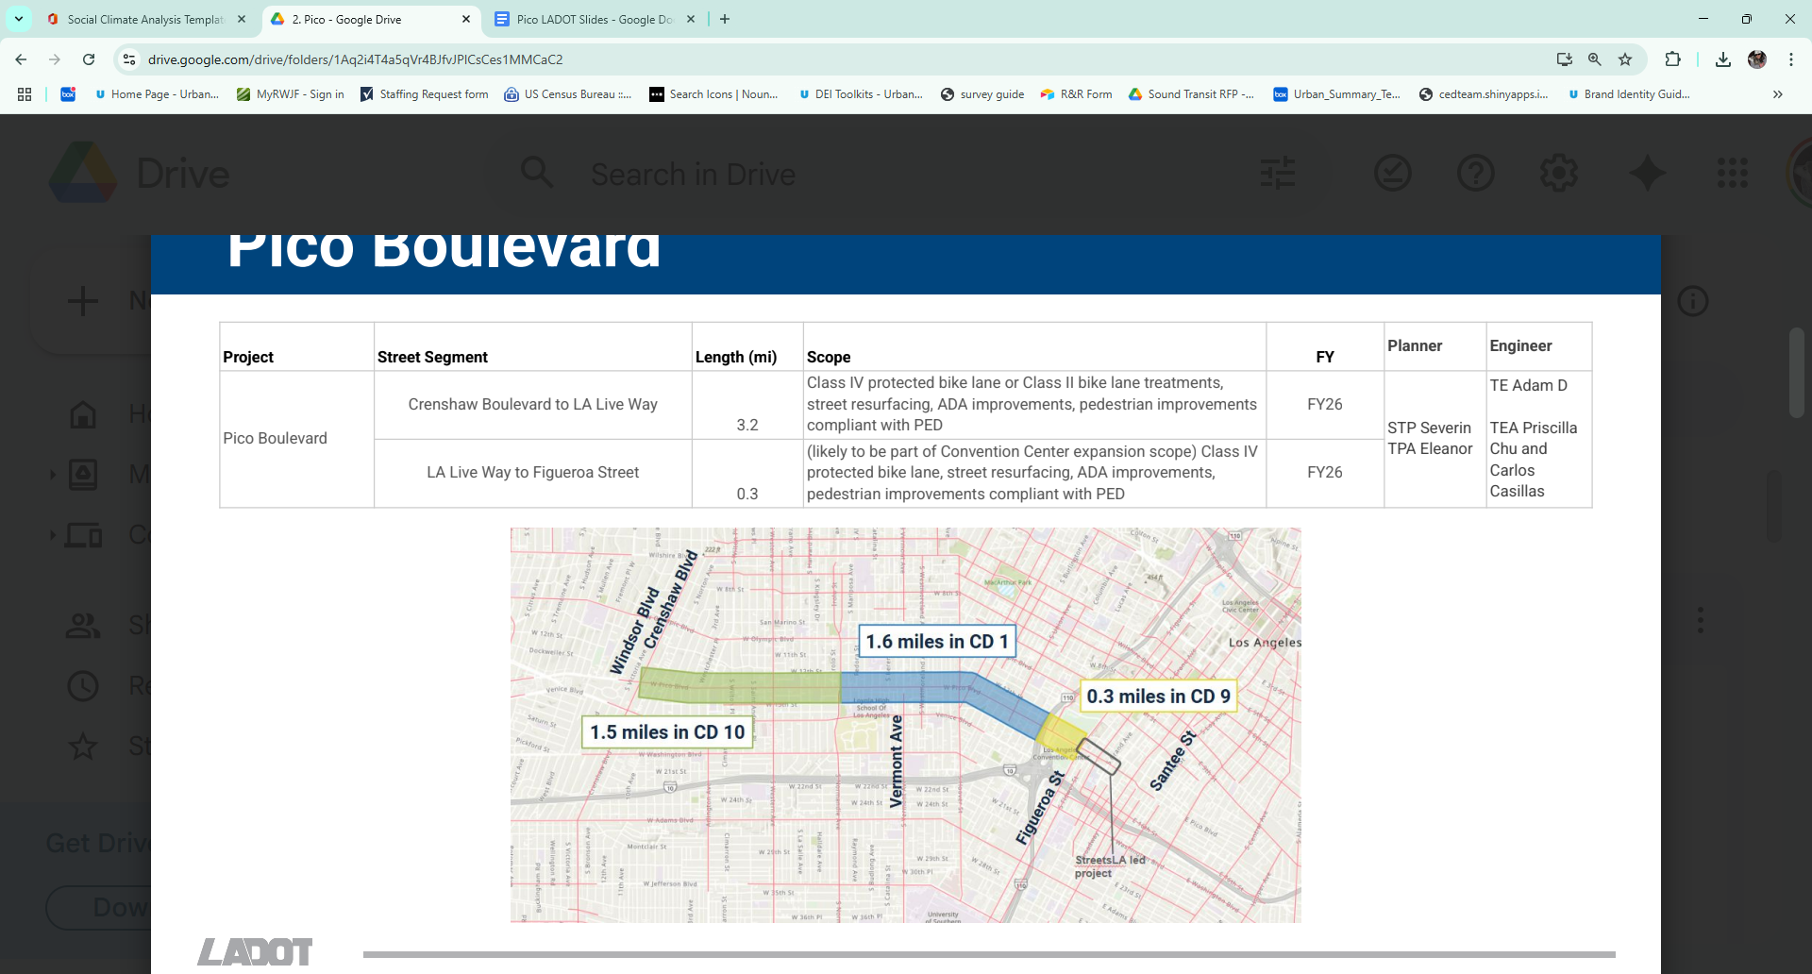

In May 2019, LADOT implemented a set of basic safety improvements between Union Avenue and 2nd Avenue. These enhancements included new traffic signals, upgraded continental crosswalks, and minor crosswalk improvements on side streets. Additional updates followed later that year. More information on these efforts can be found on LADOT’s project page (<https://ladotlivablestreets.org/projects/pico>[).](https://ladotlivablestreets.org/projects/pico-western-2nd-ave).)

In early 2024, LADOT presented a preliminary concept for a corridor redesign to City Council Districts 1, 9, and 10. This redesign aims to reconfigure the corridor and add bike lanes, improving multimodal safety and filling gaps in the City’s bicycle network. Pico Boulevard has since been designated as an Olympics-serving priority corridor, intended to enhance access to the Convention Center in Downtown Los Angeles.

The current Pico Boulevard Safety and Mobility Plan Project spans approximately 3.5 miles from Crenshaw Boulevard to Figueroa Street. The primary goals are to improve safety, reduce the frequency and severity of collisions, and strengthen bicycle connections across the city. A major focus of the project is to close a gap in the City’s bicycle network by implementing bike lanes that would link existing facilities on 4th Avenue and Figueroa Street.

Previous engagement in the Pico Study Area includes a 2017 Vision Zero community open house. LADOT also conducted outreach in the broader area as part of a Safe Routes to School initiative serving Berendo Middle School, Liechty Middle School, and Los Angeles Elementary. However, overall engagement efforts have been sporadic and lack consistent documentation.

The project falls within Council Districts 1, 9, and 10 and is currently in the planning and design phase. It is classified as a Level 3b project by LADOT’s Community Engagement Guidelines, which refers to major efforts that significantly impact multiple neighborhoods and council districts and involve notable tradeoffs.

# Section One: Study Area and Community Background

To design equitable and effective community engagement strategies, it is critical to understand the socio-economic conditions and lived experiences of residents within the Project Area—defined here as the ½-mile radius surrounding Pico Boulevard from Crenshaw Boulevard to Figueroa Street. This section provides a comprehensive demographic and socioeconomic profile of the area, drawing from the 2019–2023 American Community Survey and other publicly available datasets.

By analyzing indicators related to language access, income and poverty, housing stability, transportation patterns, and other accessibility considerations, we aim to:

* Highlight key community needs that may influence mobility and infrastructure outcomes;
* Inform culturally and contextually appropriate outreach and engagement approaches; and
* Ensure that LADOT’s programs and investments are responsive to the specific dynamics of the neighborhoods served.

The analysis includes both quantitative data visualizations and contextual interpretation to better understand disparities and access to resources and lays the foundation for equity-focused planning and engagement throughout the project.

## **Demographic Profile**

A total of 151,225 people reside in the Pico Study Area. Most census tracts within the corridor include between 2,000 to 4,000 people, with one outlier in Downtown LA where more than 7,000 people live, (Figure 2).

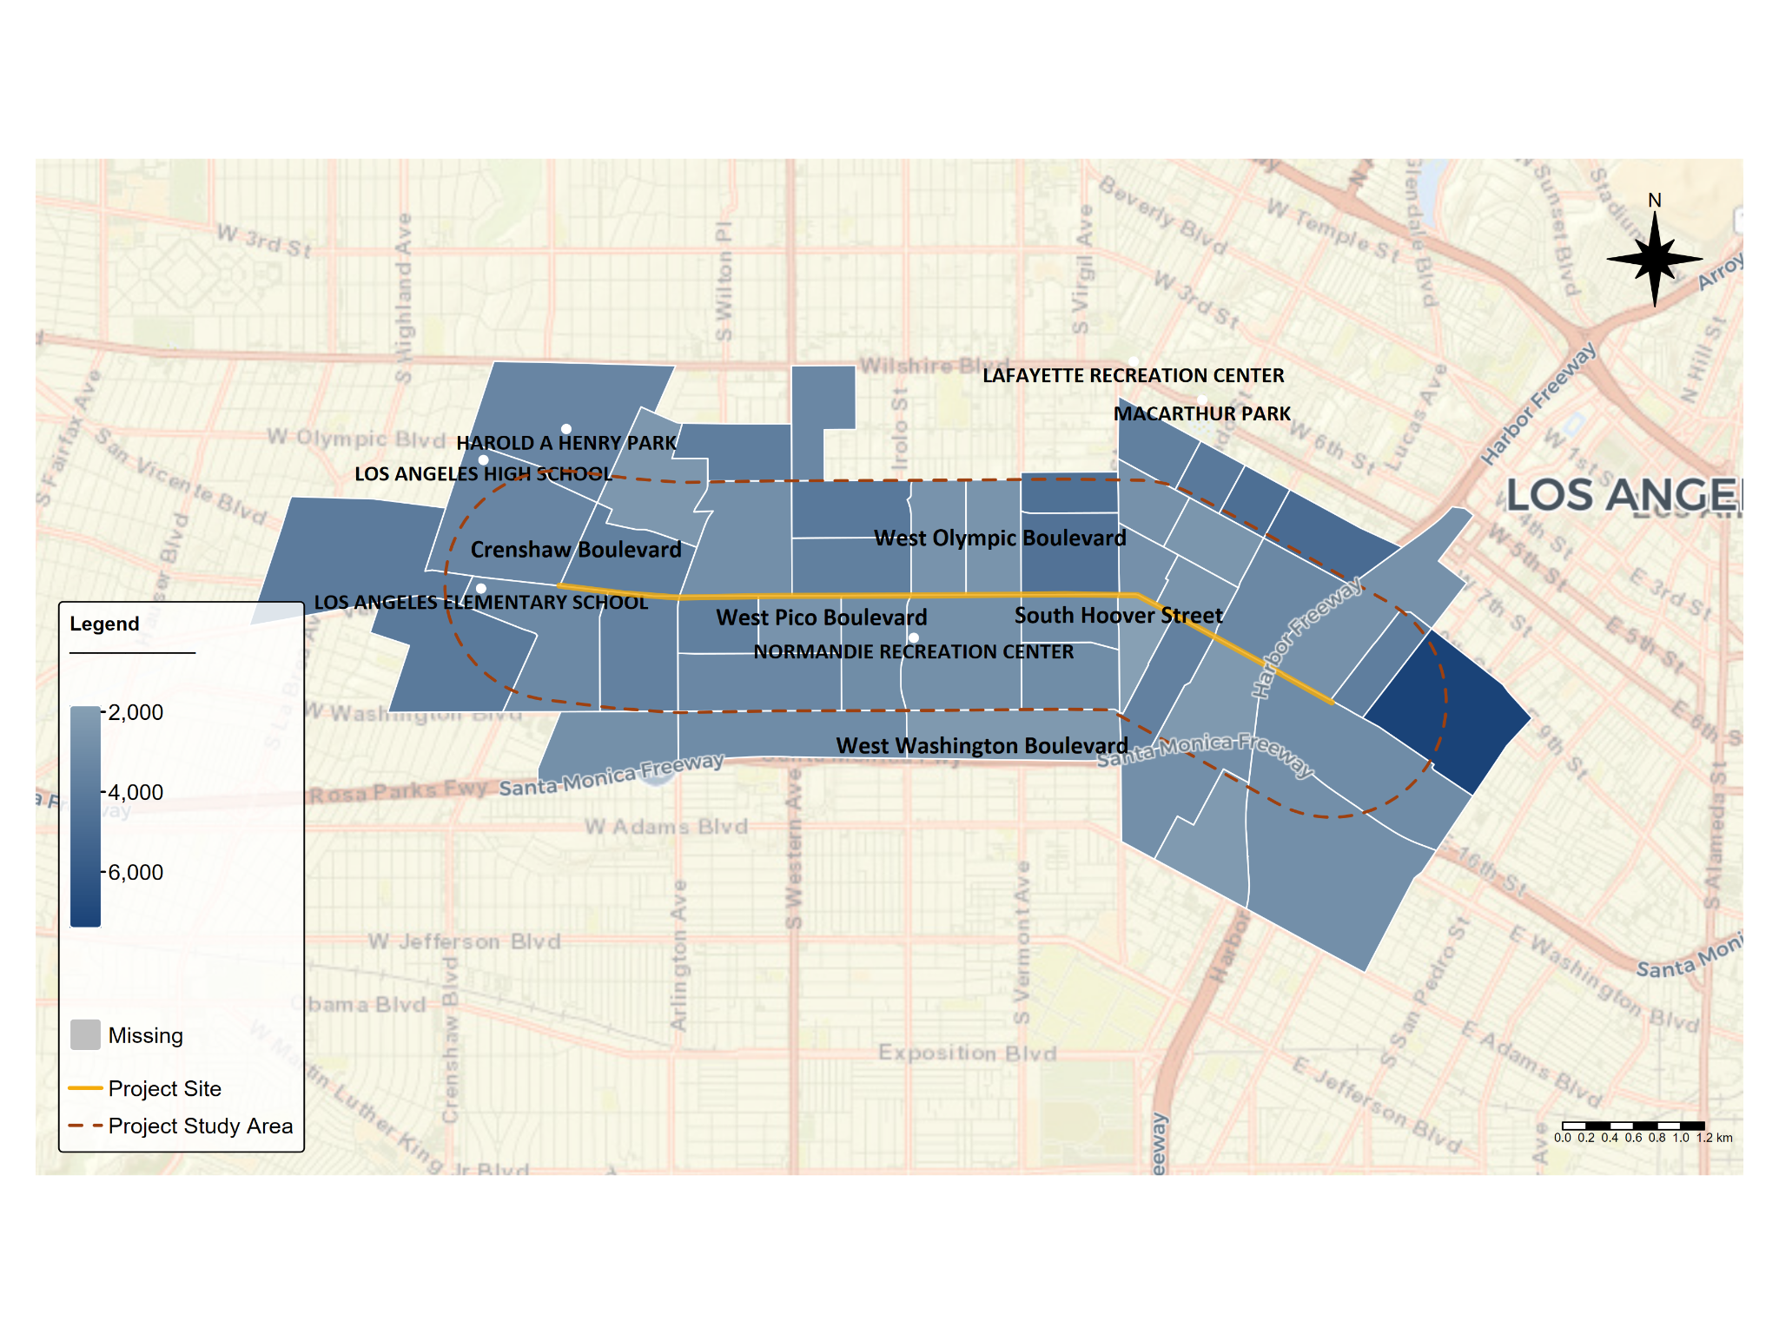

*Figure 2. Population in the Pico Study Area by Census Tract*

*Source: Authors’ analysis of 2019-2023 American Community Survey data table B01001, ‘Sex by Age’.*

Figure 3 highlights the age distribution among residents of the Pico Study Area, which we split into the groups that most closely align with generational cut points. A slight majority of residents fall between the ages of 30-44, which largely aligns with the Millennial generation while the rest are more evenly distributed.

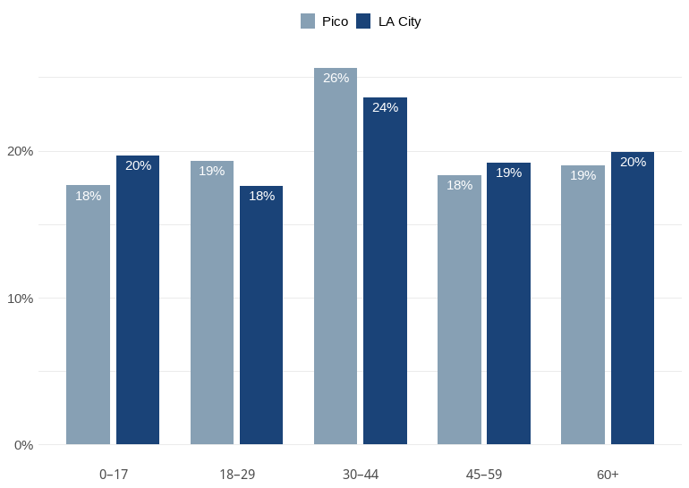

*Figure 3. Age Distribution*

*Source: Authors’ analysis of 2019-2023 American Community Survey data table B01001, ‘Sex by Age’.*

*Notes: These age brackets were selected to approximate the widely accepted bounds for generations. These do not completely align due to the brackets collected by the U.S. Census Bureau. 0-17 represents Generation Alpha (ages 0-12) and the younger end of Generation Z (ages 12-27); 18-29 represents the older end of Generation Z; 30-44 represents Generation Y or Millennials (ages 28-43); 45-59 represents Generation X (ages 44-59); and 60+ represents Baby Boomers (ages 60-78) and the Silent Generation (ages 79-100).*

As seen in Figure 4, a plurality of residents in the Pico Study Area identify as Hispanic or Latino (57 percent). A little over one-fifth of residents identify as Asian (21 percent), while under 10 percent of residents each identify as White (9.7 percent) or Black (9.1 percent).

FIGURE 4

**Ethnicity in the Pico Study Area**

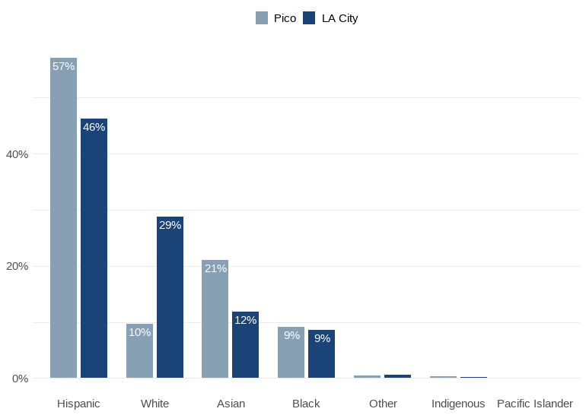

*Figure 4. Ethnicity in the Pico Study Area*

*Source: Authors’ analysis of 2019-2023 American Community Survey data table B03002, ‘Hispanic or Latino Origin by Race’.*

*Notes: All ethnicities in this figure (aside from Hispanic) refer to Non-Hispanic populations.*

Looking at residents’ income levels, a majority of census tracts have a median household income in the past 12 months around or below $50,000 (Figure 5), compared to a citywide median of _____. Only two of ____ tracts in the study area have a median household income in the past 12 months greater than $100,000 (2077.11 and 2079.02), and both are located in the easternmost part of the corridor, bordering each other.

*Figure 5. Median Income in the Past 12 Months by Census Tract*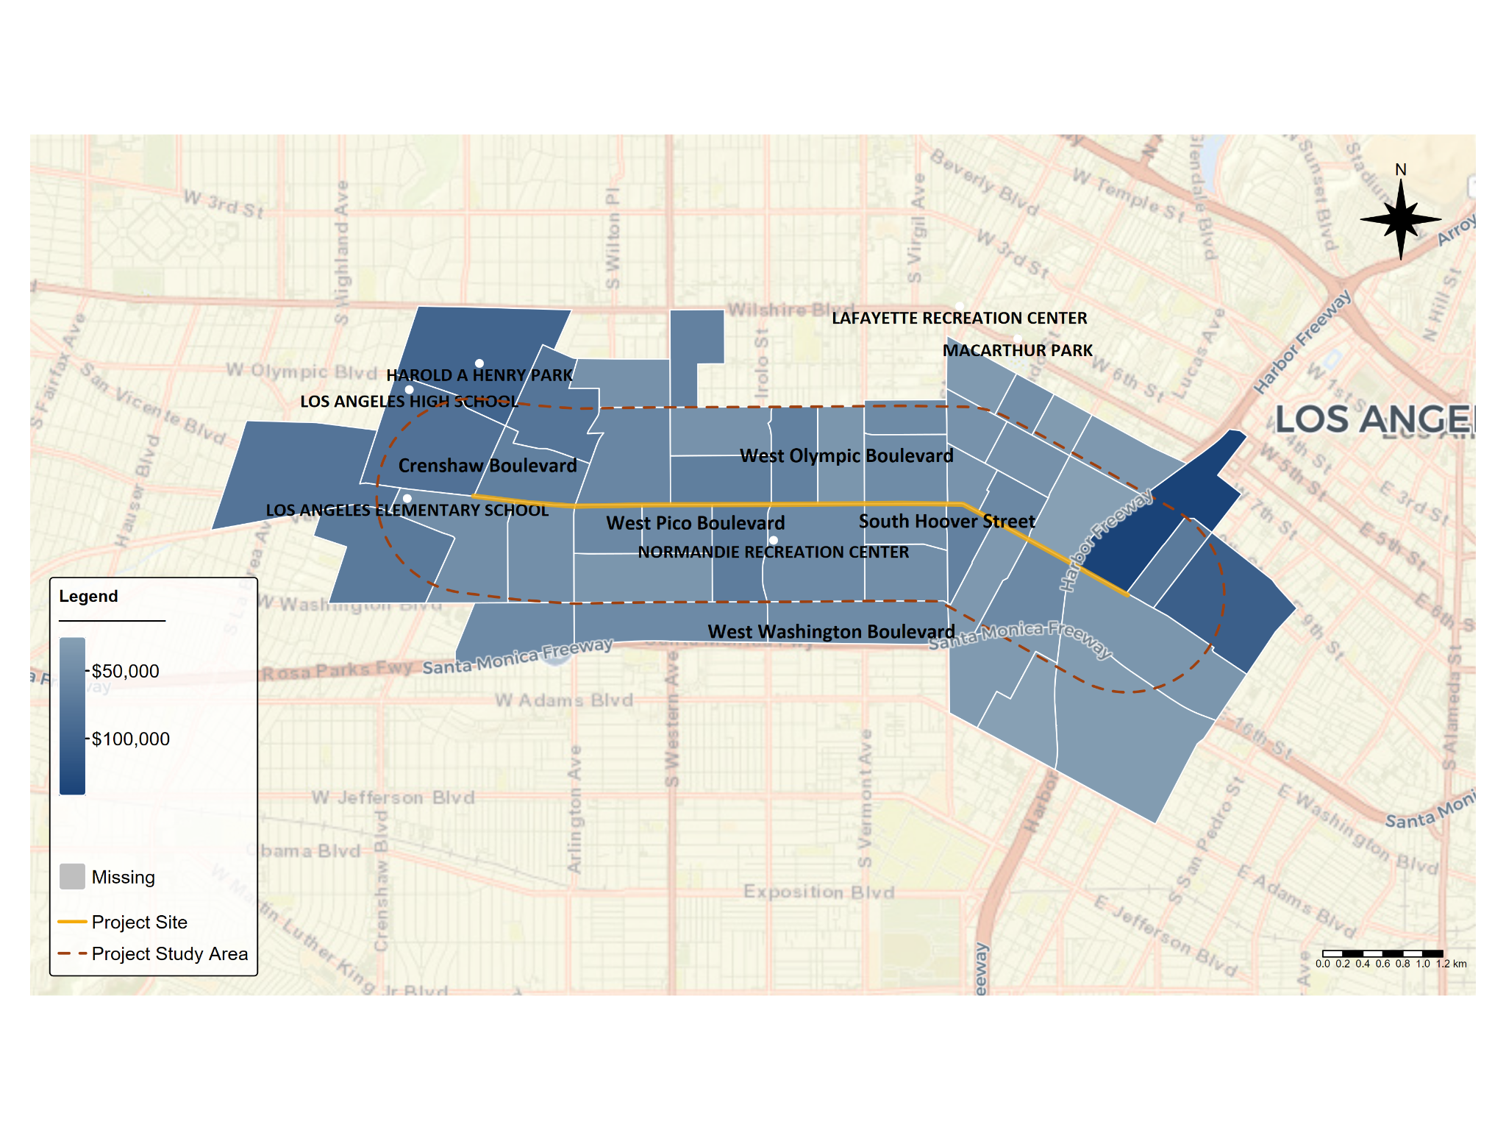

*Source: Authors’ analysis of 2019-2023 American Community Survey data table B19013, ‘Median Household Income in the Past 12 Months (in 2023 Inflation-Adjusted Dollars)’.*

Across the corridor, approximately 24 percent of the population has an income in the past 12 months below the federal poverty level. Much of this population is concentrated in the 13 census tracts where more than 30 percent of the population lives below the federal poverty line (Figure 6).

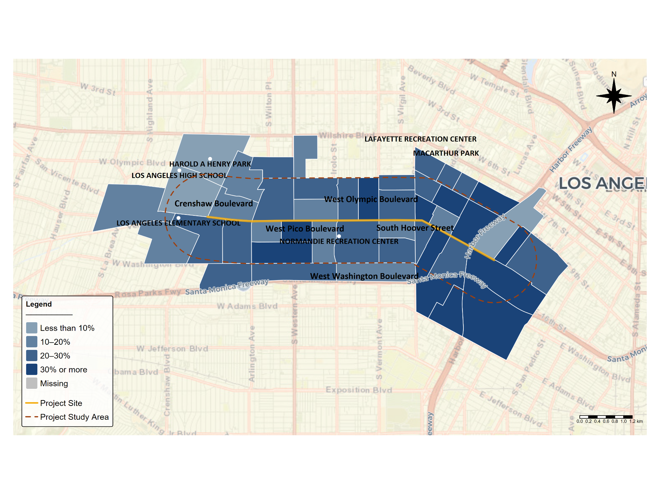

*Figure 6. Share of Households with Income in the Past 12 Months Below Poverty Level*

*Source: Authors’ analysis of 2019-2023 American Community Survey data table, B17001, ’Poverty Status in the Past 12 Months by Sex by Age’.*

In the Pico Study Area, the majority of the population 16 years and over is employed (Figure 7), while only 5 percent of working age residents are unemployed, consistent with citywide numbers. More than one third (35%) of residents in the Pico Study Area over the age of 16 are not in the labor force, meaning they may have greater ability to attend engagement sessions, and as such could be overrepresented in these activities.

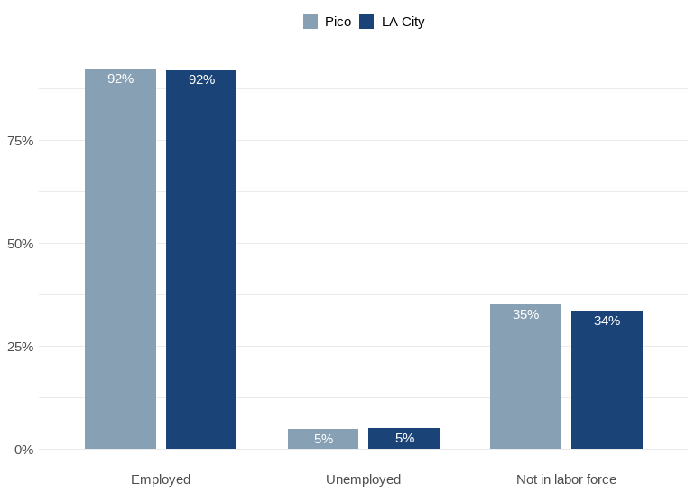

*Figure 7. Employment Status for the Population 16 Years and Over in the Pico Study Area*

*Source: Authors’ analysis of 2019-2023 American Community Survey data table B23001, ’Sex by Age by Employment Status for the Population 16 Years and Over’.*

*Notes: Percentage is based on the total population in the Pico Study Area. Data do not include residents in the Armed Forces; just over 0 percent of residents are identified as such. Employment and unemployment are calculated by dividing the number of employed/unemployed individuals by the total size of the civilian labor force. In other words, this chart shows that of the people in the labor force, 92% are employed and 5% are unemployed. Meanwhile, 35% and 34% of people are not in the labor force, meaning they are not looking for work.*

Much like the rest of the city, state, and country, the Pico Study Area is roughly evenly split by gender (Figure 8). Census tract 2094.02 has the highest share of male residents (58.9 percent), while tract 2244.20 has the highest share of female residents (61.7 percent).

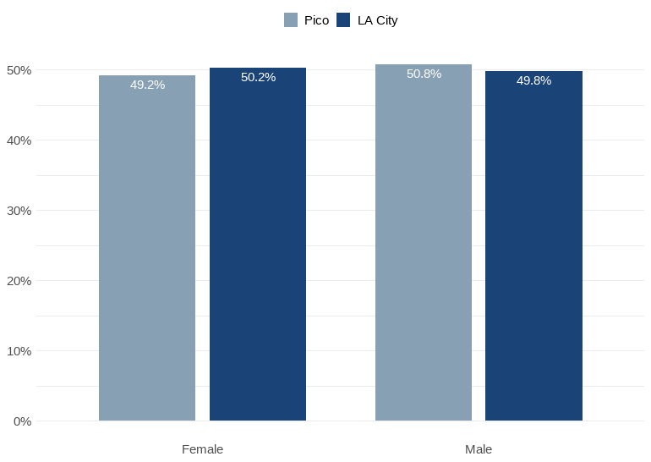

*Figure 8. Gender in the Pico Study Area*

*Source: Authors’ analysis of 2019-2023 American Community Survey data table B01001, ‘Sex by Age’.*

Roughly 12,000 households along the Pico Study Area include children under the age of 18, and just under half (47 percent) of these households are led by single parents (Figure 9). While not a substantial portion of the Pico Study Area population as a whole, this still suggests that any outreach events or activities, especially those geared to families, should be considerate of the childcare needs of attendees.

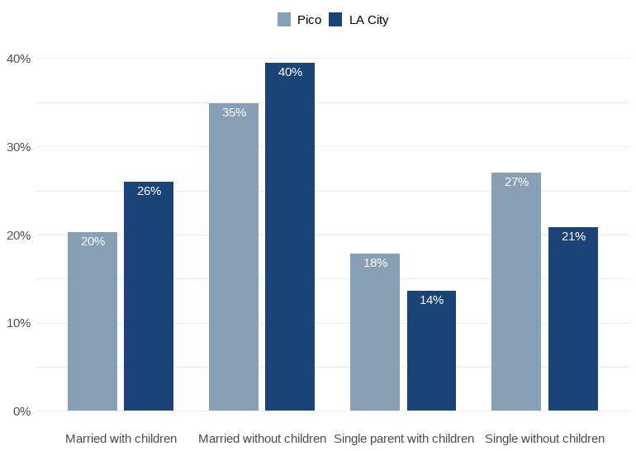

*Figure 9. Family Type by Presence and Age of Own Children Under 18 Years in the Pico Study Area*

*Source: Authors’ analysis of 2019-2023 American Community Survey data table B11003, ‘Family Type by Presence and Age of Own Children Under 18 Years’.*

## **Language Access and Cultural Considerations**

Much like the greater city of Los Angeles, the Pico Study Area is a diverse area where residents speak multiple languages at home, with a varying degree of ability to speak English (Figure 10). The plurality, but not the majority (43%), of the Pico Study Area has the ability to speak English “very well”, compared to 38% of people who either speak English “not well” (25%) or “not at all” (13%). As a result, outreach materials should not be exclusively in English and when presented in English should use more colloquial language.

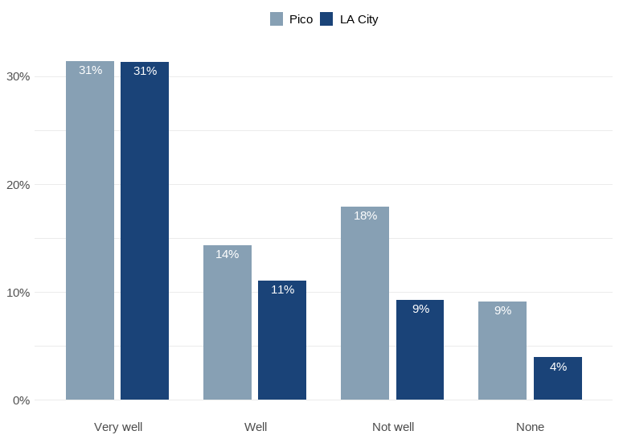

*Figure 10. Number of Individuals with the Ability to Speak English in the Pico Study Area*

*Source: Authors’ analysis of 2019-2023 American Community Survey data table B16004, ’Age by Language Spoken at Home by Ability to Speak English for the Population 5 Years and Over’.*

Figure 11 depicts the share of the Pico Study Area that speaks another language at home, regardless of their level of their ability to speak English. Of the alternative language options, Spanish language materials should clearly be prioritized, as more than half of residents along the corridor speak Spanish at home. While these residents may also have the ability to speak English, a clear majority of the corridor has some level of Spanish proficiency. Meanwhile, just over 13% of residents speak Korean. Another 2% speak Chinese, and 5% speak other languages at home.

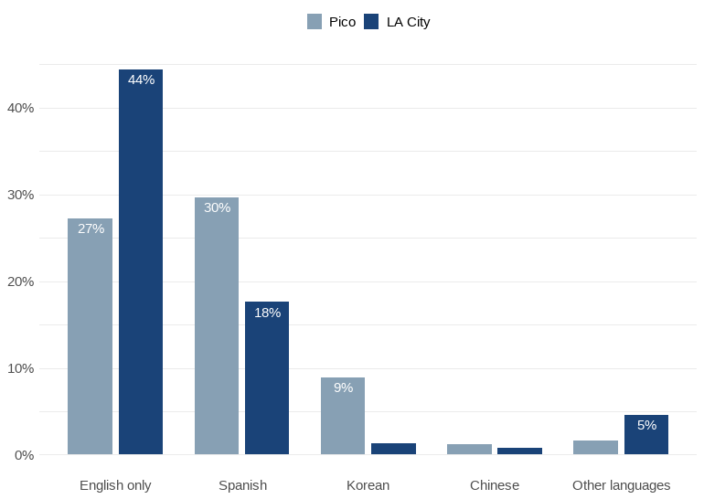

*Figure 11. Other Languages Spoken at Home in the Pico Study Area for Individuals Who Do Not Speak English Very Well*

*Source: Authors’ analysis of 2019-2023 American Community Survey data table C16001, ’Language Spoken at Home for the Population 4 Years and Over’.*

When mapping the location of households where other languages are spoken, there are clear concentrations by language. In almost every tract in the Pico Study Area, at least one fifth of households are Spanish-speaking (Figure 12). Yet tracts in the eastern portion of the corridor have significantly higher concentrations of Spanish speakers than those in the western portion. Meanwhile, there is no one census tract where more than 50 percent of households speak Korean (Figure 13), but there are three in the western portion of the corridor where more than 40 percent of households do.

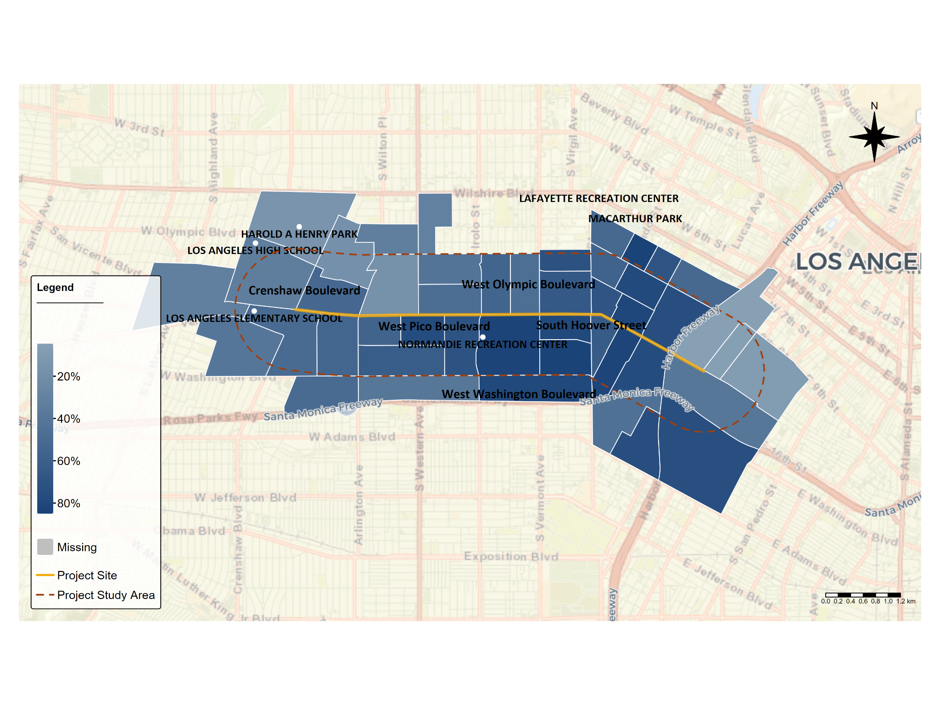

*Figure 12. Share of Population that Speaks Spanish At Home by Census Tract*

*Source: Authors’ analysis of 2019-2023 American Community Survey data table C16001,’Language Spoken at Home for the Population 4 Years and Over’.*

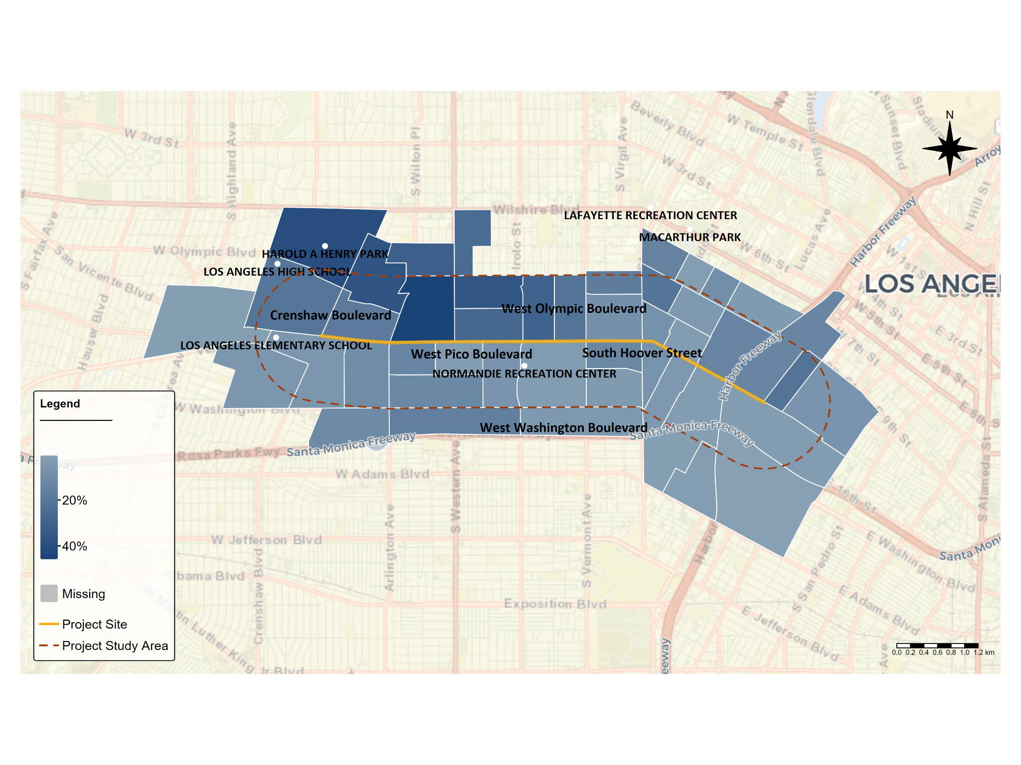

*Figure 13. Share of Population that Speaks Korean at Home by Census Tract*

*Source: Authors’ analysis of 2019-2023 American Community Survey data table C16001, ’Language Spoken at Home for the Population 4 Years and Over’.*

According to Census estimates, just under half (48 percent) of residents in the Pico Study Area were born in a country outside of the United States (Table 1) and alongside findings in Figure 11, supports the recommendation that outreach materials should prioritize translation into Spanish and Korean .

|  |  |  |
| --- | --- | --- |
| Country | Population | Percentage |
| Mexico | **20,140** | **13.3%** |
| Korea | **16,057** | **10.6%** |
| El Salvador | **11,581** | **7.7%** |
| Guatemala | **10,155** | **6.7%** |
| China | **3,537** | **2.3%** |
| Philippines | **1,764** | **1.2%** |
| Honduras | **1,608** | **1.1%** |

*Table 1. Most Popular Countries of Origin in the Pico Study Area*

*Source: Authors’ analysis of 2019-2023 American Community Survey data table B05006, ‘Place of Birth for the Foreign-Born Population in the United States’.*

*Notes: Table includes all of the countries with a population greater than 1,000.*

## **Other Accessibility Considerations**

Another important consideration when conducting community engagement is whether there are residents with mobility limitations or other disabilities in the community. Similar to the rest of Los Angeles County, approximately 11 percent of residents in the Pico Study Area have a disability. However, individuals with disabilities do not tend to live uniformly across census tracts. Rather, individuals with disabilities are more likely to live in certain tracts in the western, northeastern, and southeastern areas of Pico Boulevard (Figure 14). In several cases, over 15 percent of a tract’s population has a disability, and there are nine census tracts where over 500 individuals have a disability. However, because of small sample sizes, disability estimates at the census tract level are subject to large margins of error and should be interpreted with caution.

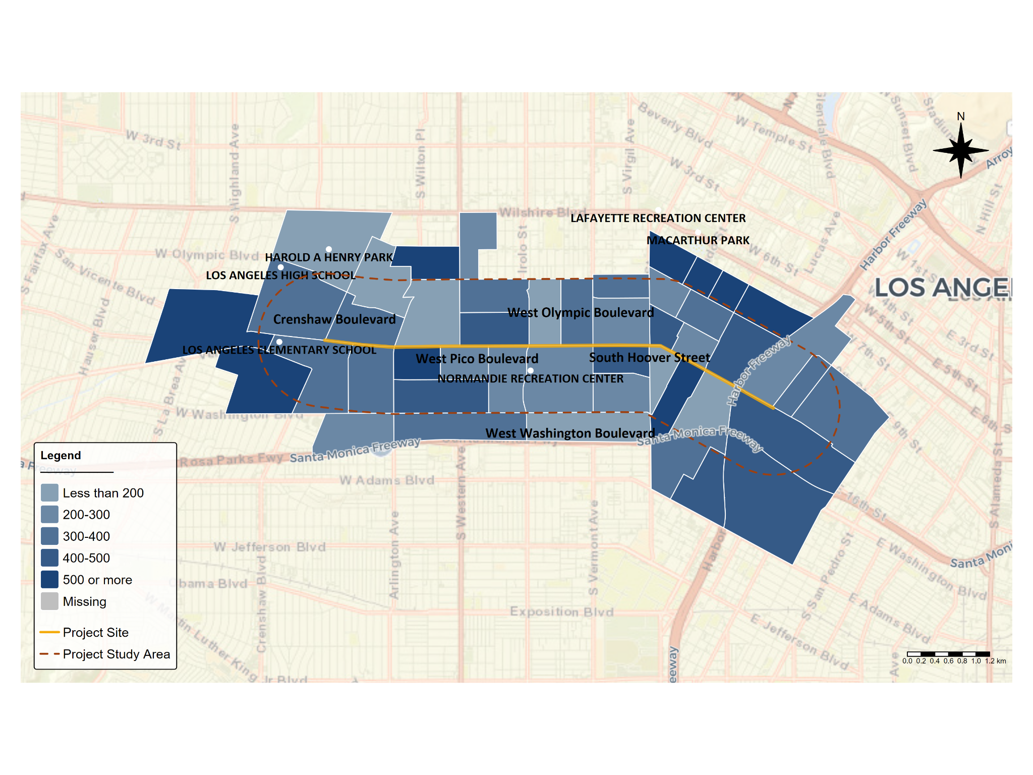

*Figure 14. Number of Individuals with a Disability, by Census Tract*

*Source: Authors’ analysis of 2019-2023 American Community Survey data table B18101, ‘Sex by Age by Disability Status’.*

There is also substantial variation between census tracts with respect to the number of individuals with a vision difficulty (Figure 15). Though the median census tract in the Pico Study Area has 65 individuals with a vision difficulty, as few as zero and as many as 243 individuals have a vision impairment across the Study Area. The skew in the distribution of individuals with vision difficulties across tracts is driven by a subset of census tracts with a high number of individuals with a vision impairment. For instance, a concentration of census tracts in the eastern part of the Pico Study Area have over 150 individuals with a vision impairment in each tract.

A similar pattern emerges when observing the number of individuals with a hearing difficulty across the Pico Study Area. While fewer than three percent of individuals have a hearing difficulty in most census tracts, a handful of tracts have a much higher concentration of hearing-impaired individuals (Figure 16). Eleven census tracts have over 100 individuals with a hearing difficulty, with the highest number being 256.

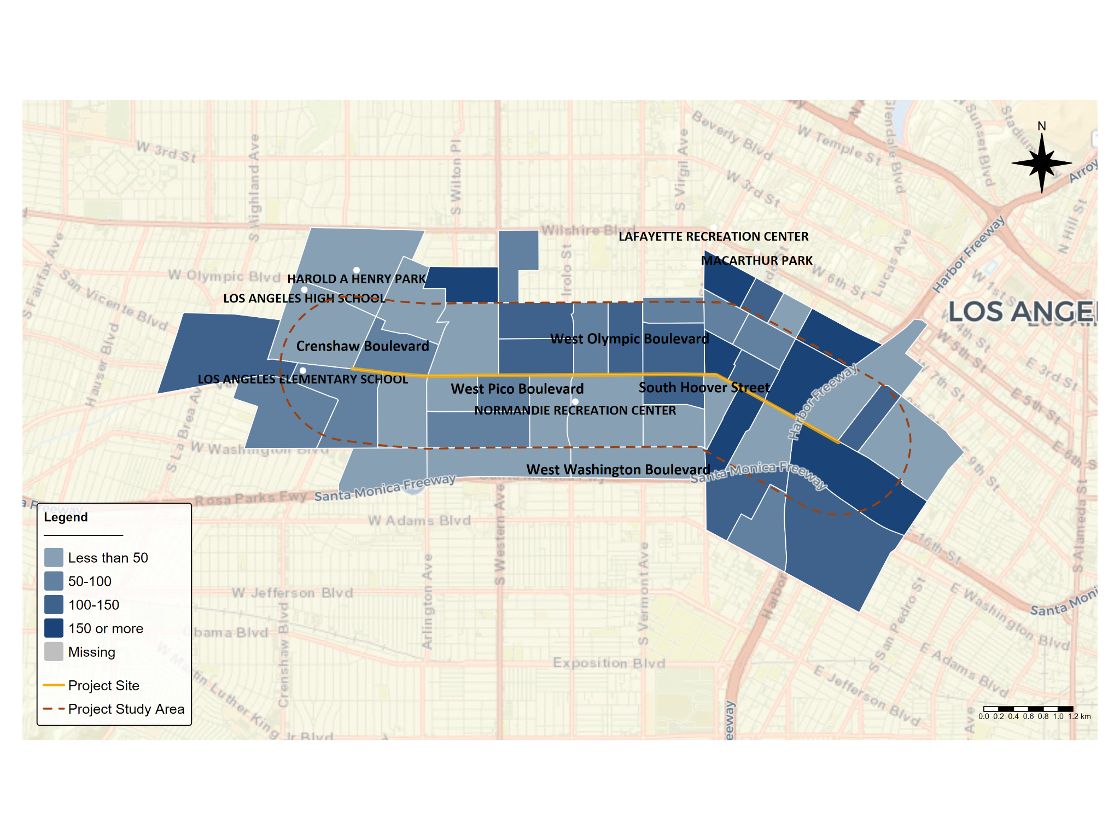

*Figure 15. Number of Individuals with Vision Difficulties, by Census Tract*

*Source: Authors’ analysis of 2019-2023 American Community Survey data table B18103, ’Sex by Age by Vision Difficulty’.*

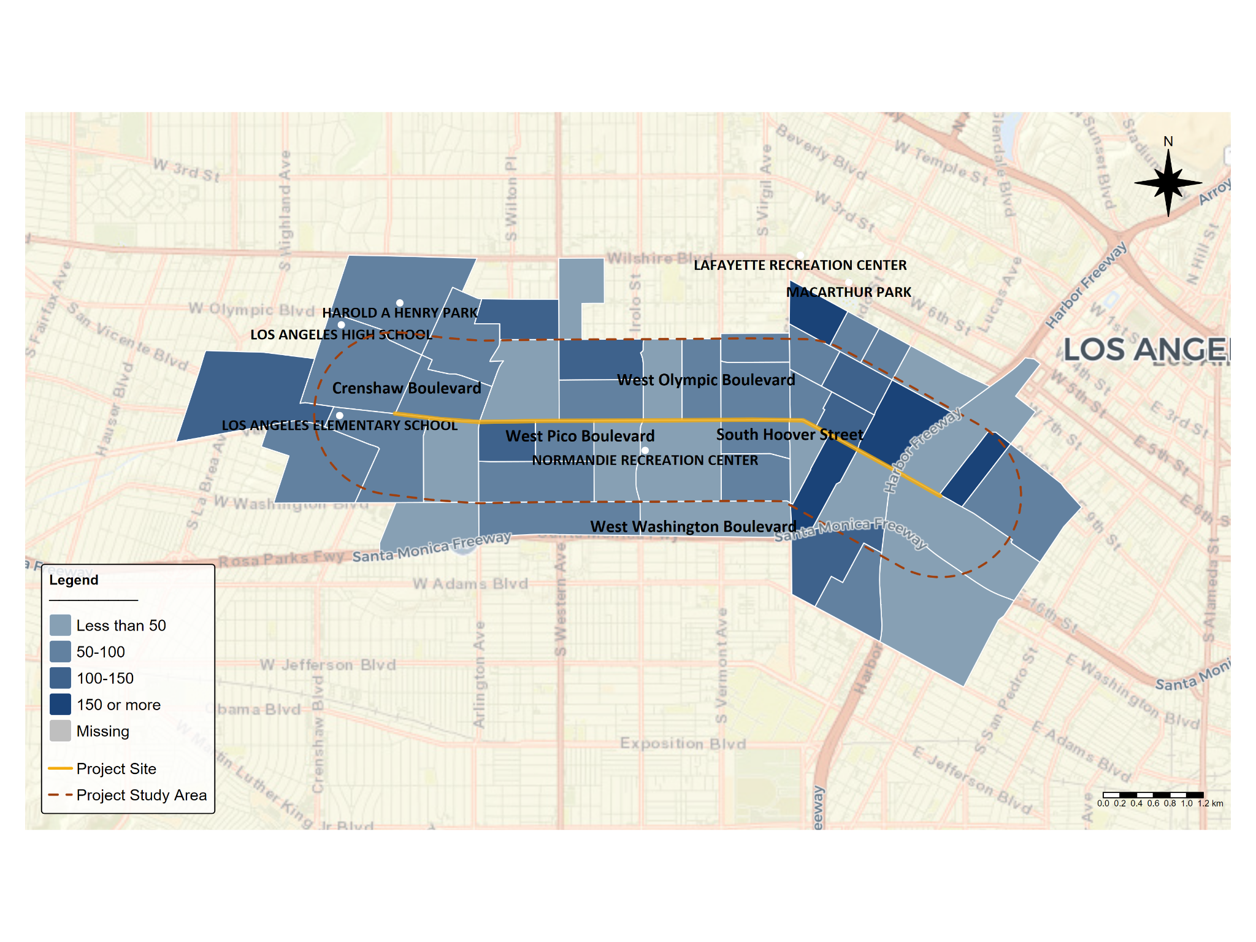

*Figure 16. Number of Individuals with Hearing Difficulty, by Census Tract*

*Source: Authors’ analysis of 2019-2023 American Community Survey data table B18102, ’Sex by Age by Hearing Difficulty’.*

Individuals with an ambulatory difficulty, or serious difficulty walking or climbing stairs, are more uniformly located across census tracts in comparison to other types of disabilities. But while individuals with an ambulatory difficulty tend to live in all locations, there are still specific census tracts where they are more likely to live. Similar to the patterns of other disabilities, census tracts in the western, northeastern, and southeastern parts of the Pico Study Area have a higher number of individuals with an ambulatory difficulty (Figure 17).

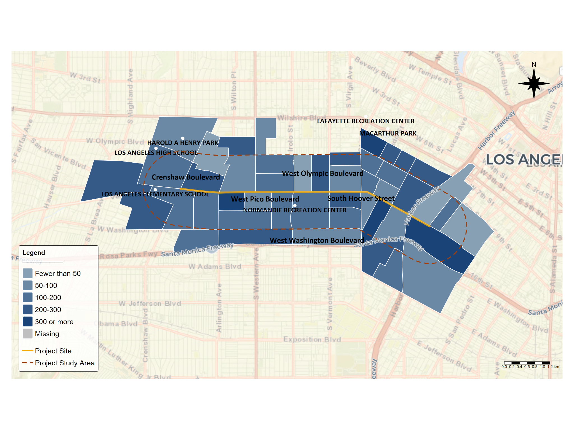

*Figure 17. Number of Individuals with an Ambulatory Difficulty, by Census Tract*

*Source: Authors’ analysis of 2019-2023 American Community Survey data table B18105, ’Sex by Age by Ambulatory Difficulty’.*

Access to broadband and technology is essential for enabling individuals to be aware of changes in their community as well as for ensuring that outreach methods are accessible to all. Yet, there are large disparities in access to internet across census tracts in the Pico Study Area. While the western portion of the corridor generally has high levels of internet access, many areas in the eastern half lack access (Figure 18). For instance, there are several tracts in the eastern portion of the corridor where over 20 percent of households lack access to internet, and there are three census tracts where at least 30 percent of households lack access.

A similar pattern emerges when observing the spatial pattern of households without access to a device (Figure 19). There are ten census tracts where over 10 percent of households lack access to a device. These tracts are predominantly concentrated in the eastern portion of the corridor.

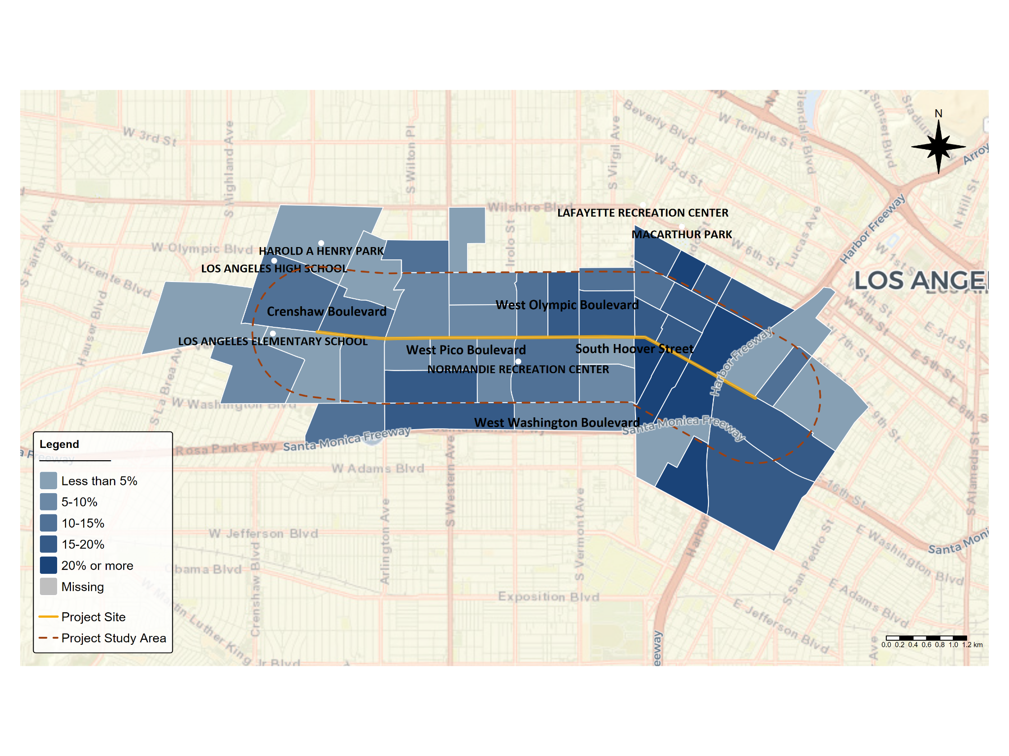

*Figure 18. Share of Households with No Internet Access, by Census Tract*

*Source: Authors’ analysis of 2019-2023 American Community Survey data table B28002, ’Presence and Types of Internet Subscriptions in Households’.*

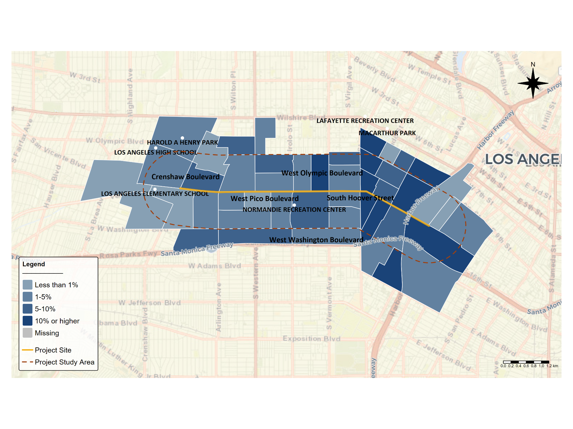

*Figure 19. Share of Households Without Access to a Computing Device, by Census Tract*

*Source: Authors’ analysis of 2019-2023 American Community Survey data table B28001, ’Types of Computers in Household’.*

*Notes: A computing device is defined as a desktop or laptop, smartphone, tablet or other portable wireless computer, or other computer.*

Across all census tracts in the Pico Study Area, 95 percent of households have access to one or more types of a computing device (Figure 20). The most common type of computing device that households have access to is a smartphone (91 percent), followed by a desktop or laptop (73 percent) and a tablet, other portable wireless computer, or another type of computer (58 percent). While many households own multiple types of computing devices, approximately 15 percent exclusively have access to a smartphone with no other type of computing device. Just over one percent of households only have access to desktops and laptops, and less than one percent of households only have access to tablets and other portable wireless computers.

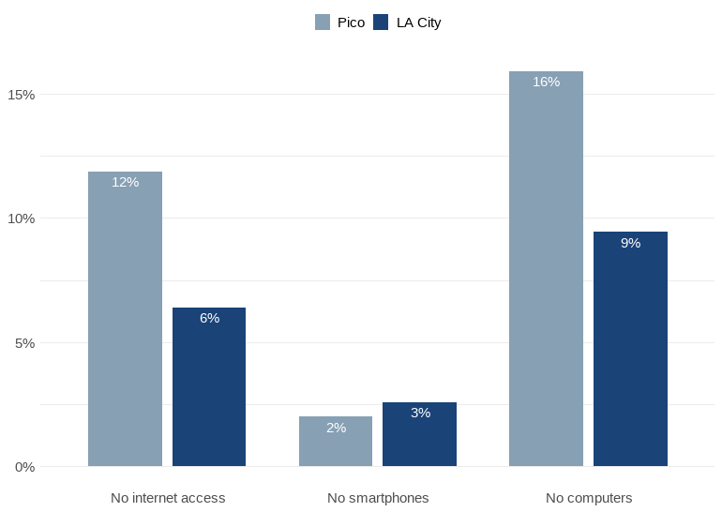

*Figure 20. Device Access Across All Census Tracts.*

*Source: Authors’ analysis of 2019-2023 American Community Survey data table B28001, ’Types of Computers in Household’.*

## **Housing**

A much higher share of households in the Pico Study Area are renter-occupied relative to the rest of Los Angeles (Figure 21). In all census tracts in the Pico Study Area, the majority of households are renters. In the average census tract in the corridor, roughly 86 percent of households are renters. There are 22 census tracts where over 90 percent of occupied housing units are renter-occupied, and one census tract where 100 percent of occupied housing units are. While renter-occupied units are spread out throughout the corridor, they are highly concentrated in the eastern part of the corridor (Figure 22).

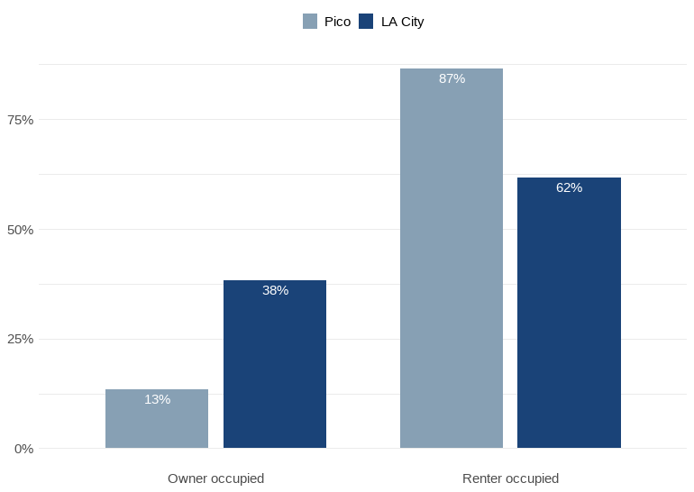

*Figure 21. Share of Occupied Housing Units by Tenure*

*Source: Authors’ analysis of 2019-2023 American Community Survey data table B25003, ’Tenure’.*

*Notes: Percentage is calculated by dividing the number of owner/renter occupied housing units by the total number of occupied housing units.*

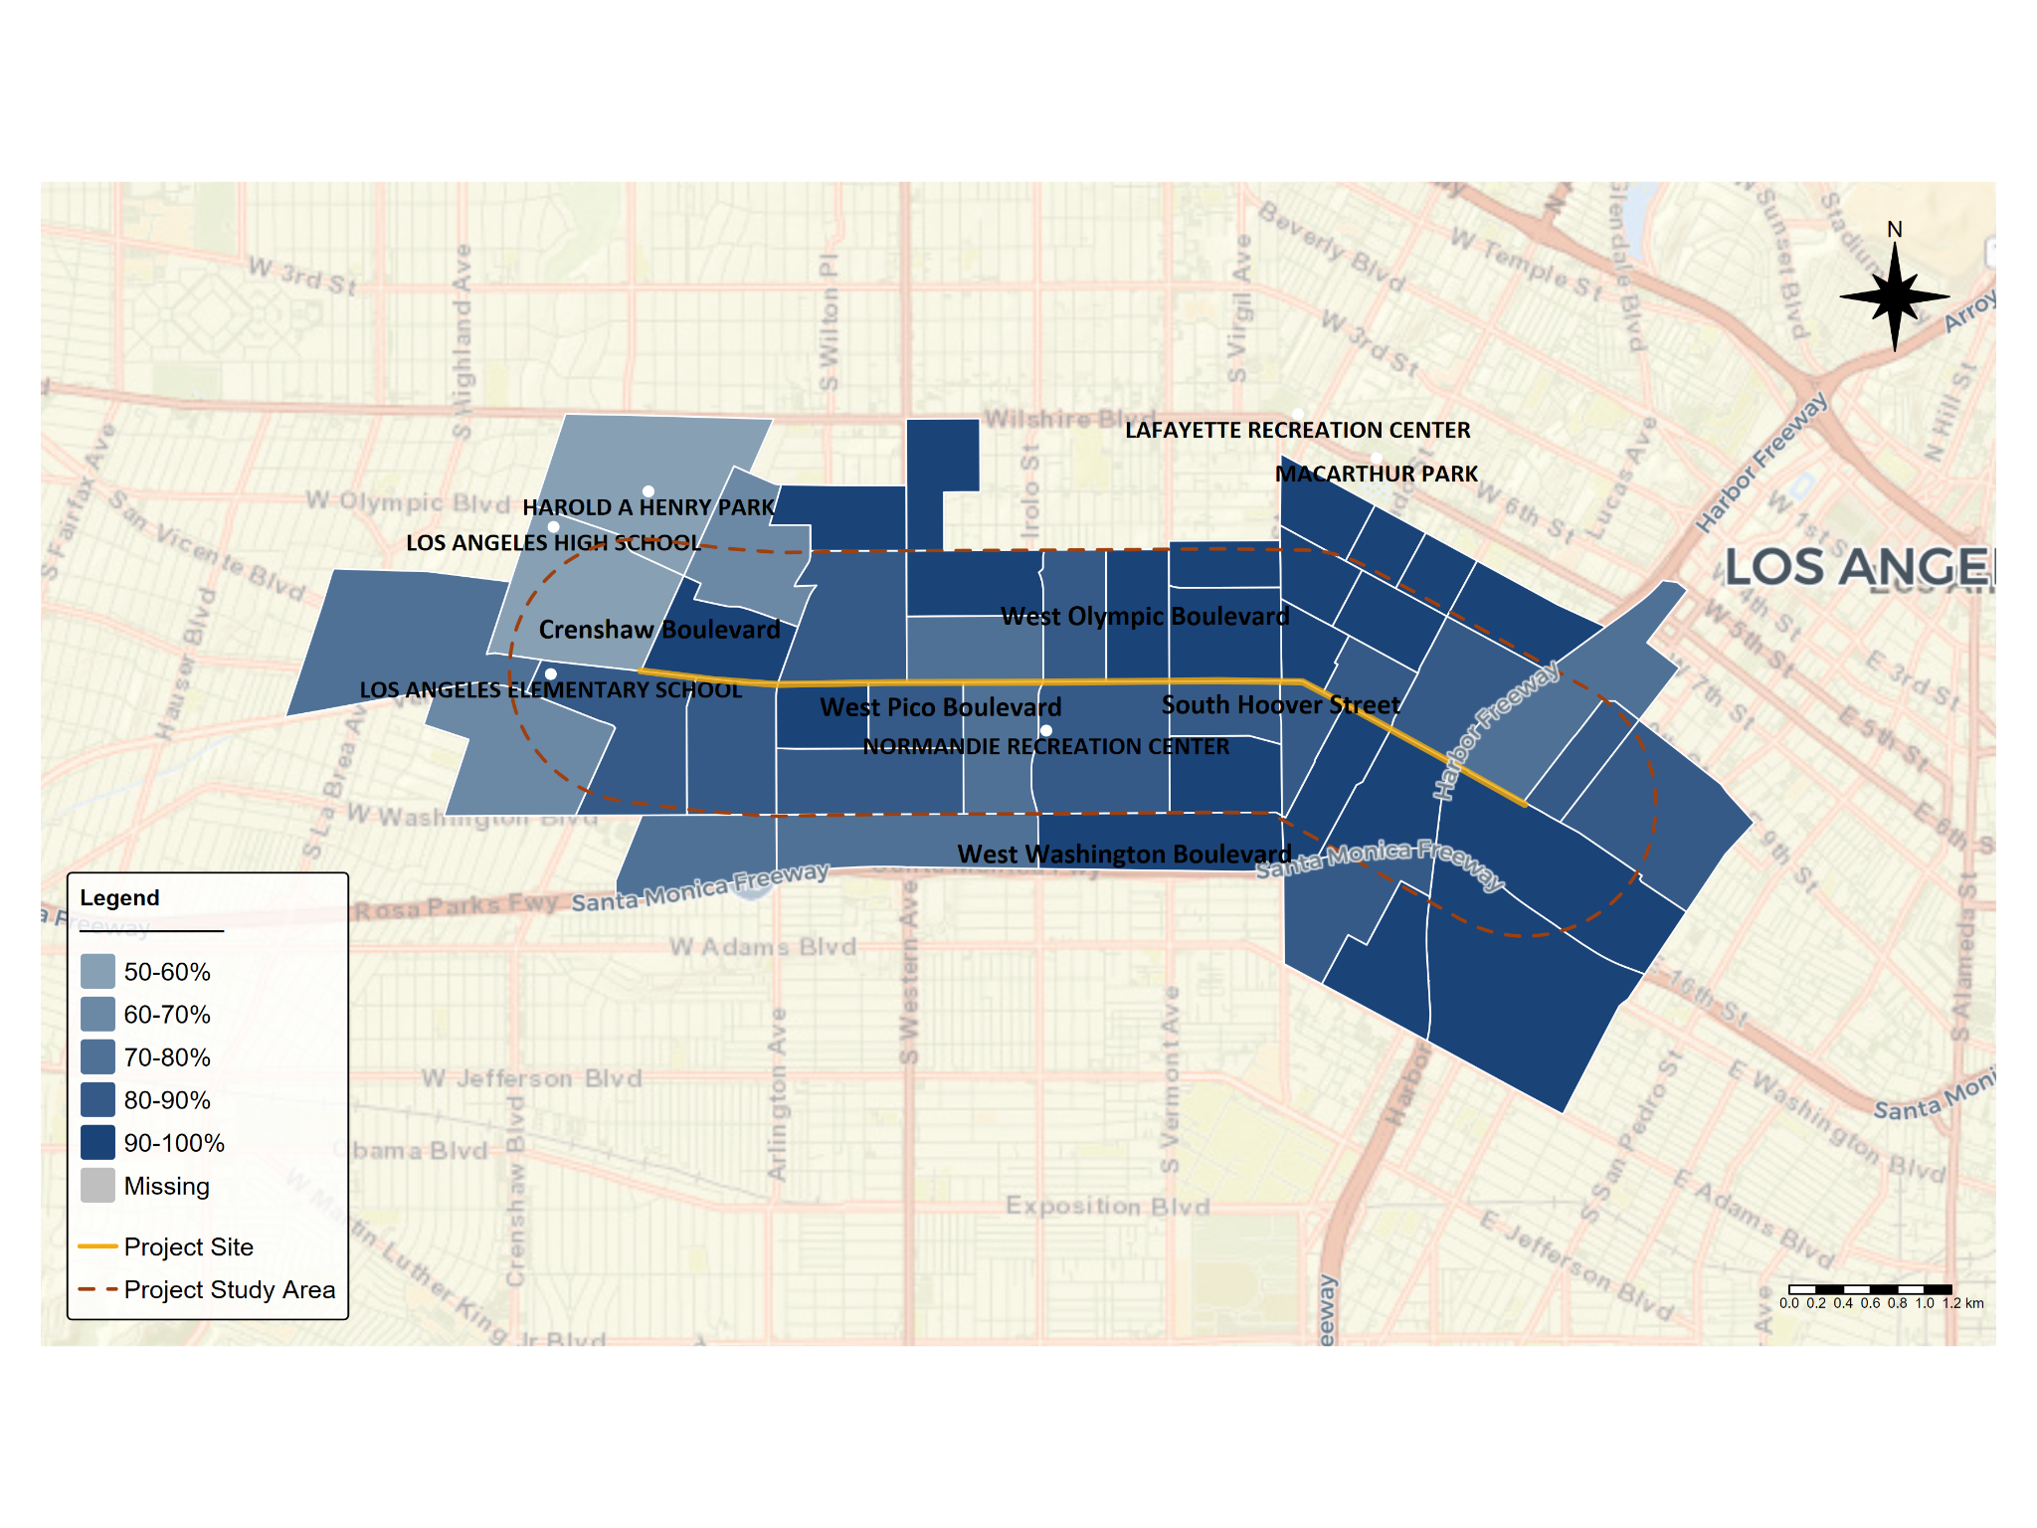

*Figure 22. Share of Occupied Housing Units that are Rented.*

*Source: Authors’ analysis of 2019-2023 American Community Survey data table B25003, ’Tenure’.*

A large proportion of renters in the Pico Study Area are cost burdened, typically defined as spending at least 30 percent of their household income on housing. There are only six census tracts where the median gross rent as a percentage of household income in the past 12 months is less than 30 percent, meaning that the typical household in 40 census tracts is cost burdened (Figure 23). There are six tracts where the median household spends over 40 percent of the income on housing.

Moreover, there are 37 census tracts where over half of households are rent burdened, and 3 census tracts where over 70 percent of households are rent burdened (Figure 24). A high share of households across Pico tracts are severely rent burdened, defined as the gross rent as a percentage of household income in the past 12 months exceeding 50 percent (Figure 25).

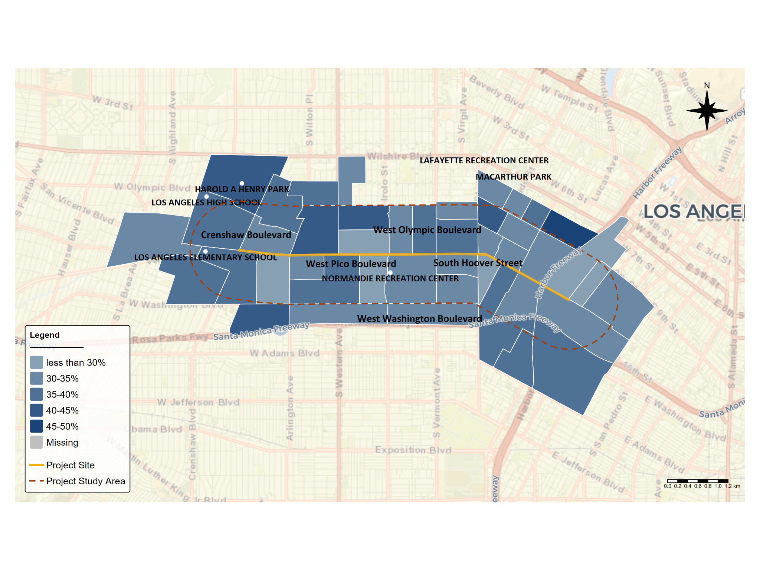

*Figure 23. Median Gross Rent as a Percentage of Household Income in the Past 12 Months*

*Source: Authors’ analysis of 2019-2023 American Community Survey data table B25071_001, ’Median Gross Rent as a Percentage of Household Income in the Past 12 Months (Dollars)’.*

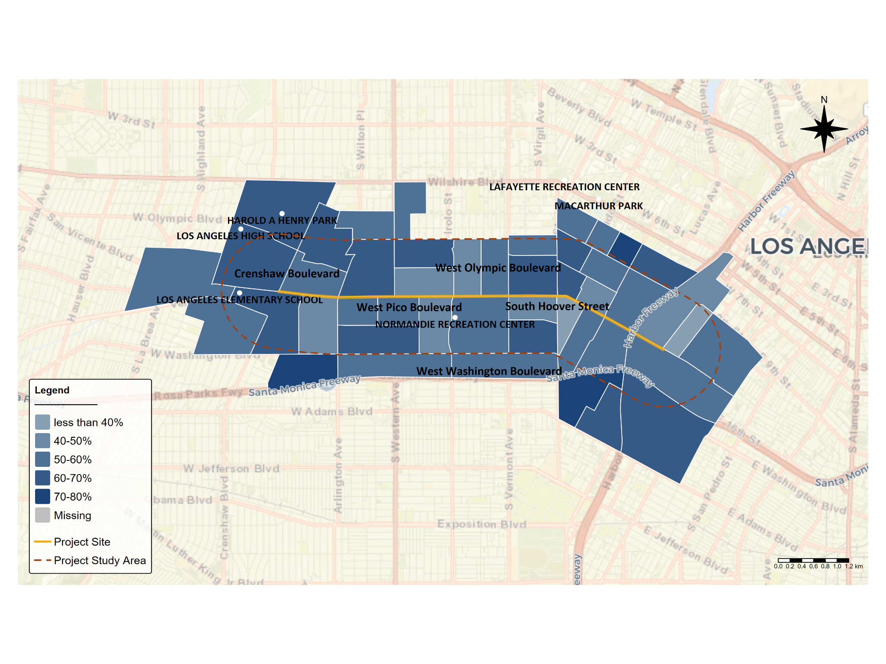

*Figure 24. Share of Households that are Rent Burdened*

*Source: Authors’ analysis of 2019-2023 American Community Survey data table B25070, ’Gross Rent as a Percentage of Household Income in the Past 12 Months’.*

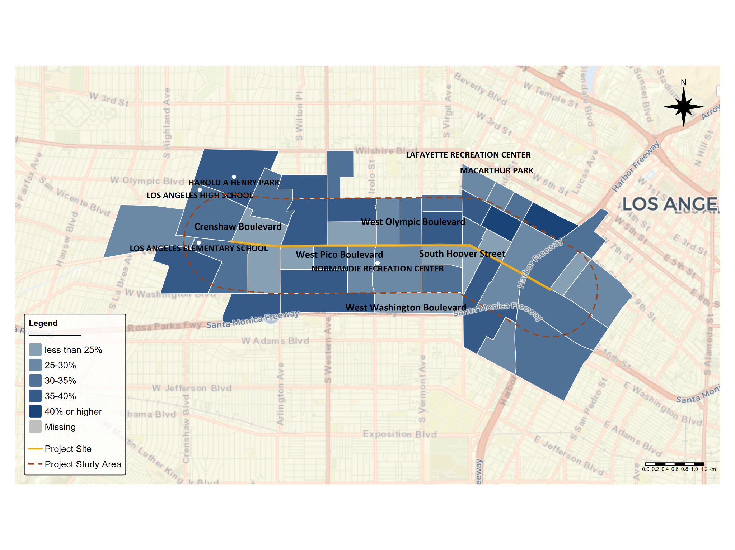

*Figure 25. Share of Households that are Severely Rent Burdened*

*Source: Authors’ analysis of 2019-2023 American Community Survey data table B25070, ’Gross Rent as a Percentage of Household Income in the Past 12 Months’.*

In 2012, California established a definition of “disadvantaged communities” (DACs) under Senate Bill 535. The purpose of this definition is to facilitate the targeting of strategic investments aiming to improve public health and economic opportunity to more burdened and resource-constrained communities. Generally, DACs are census tracts that suffer from high levels of pollution and environmental degradation and are the most economically distressed. In the Pico Study Area, 40 of 46 total census tracts meet this definition, highlighting the environmental and economic distress faced by the majority of community members.

The Pico Study Area includes a number of properties designated as affordable housing (Figure 26). In total, there are 266 properties located in the census tracts that are located in part of the study area. They are clustered East of Hoover Street with fewer located in the middle of the study area, although there are a number located south of Pico Boulevard and between Western and Arlington Avenues. According to Everyone in LA’s Affordable Housing Map[1], there are 10,312 existing affordable housing units within 2 miles of the Pico Study Area’s midpoint, and 830 more in the construction pipeline. The area also includes 4,476 units of supportive housing and 342 units of immediate housing. While the Everyone in LA’s area does not exactly align with that of the study area, it provides a sense of the scope of affordable housing nearby.

Meanwhile, there are fewer senior housing properties in the census tracts that make up the study area (Figure 27), and in fact there is only one property located within the study area itself, the Freeman Villa apartments.

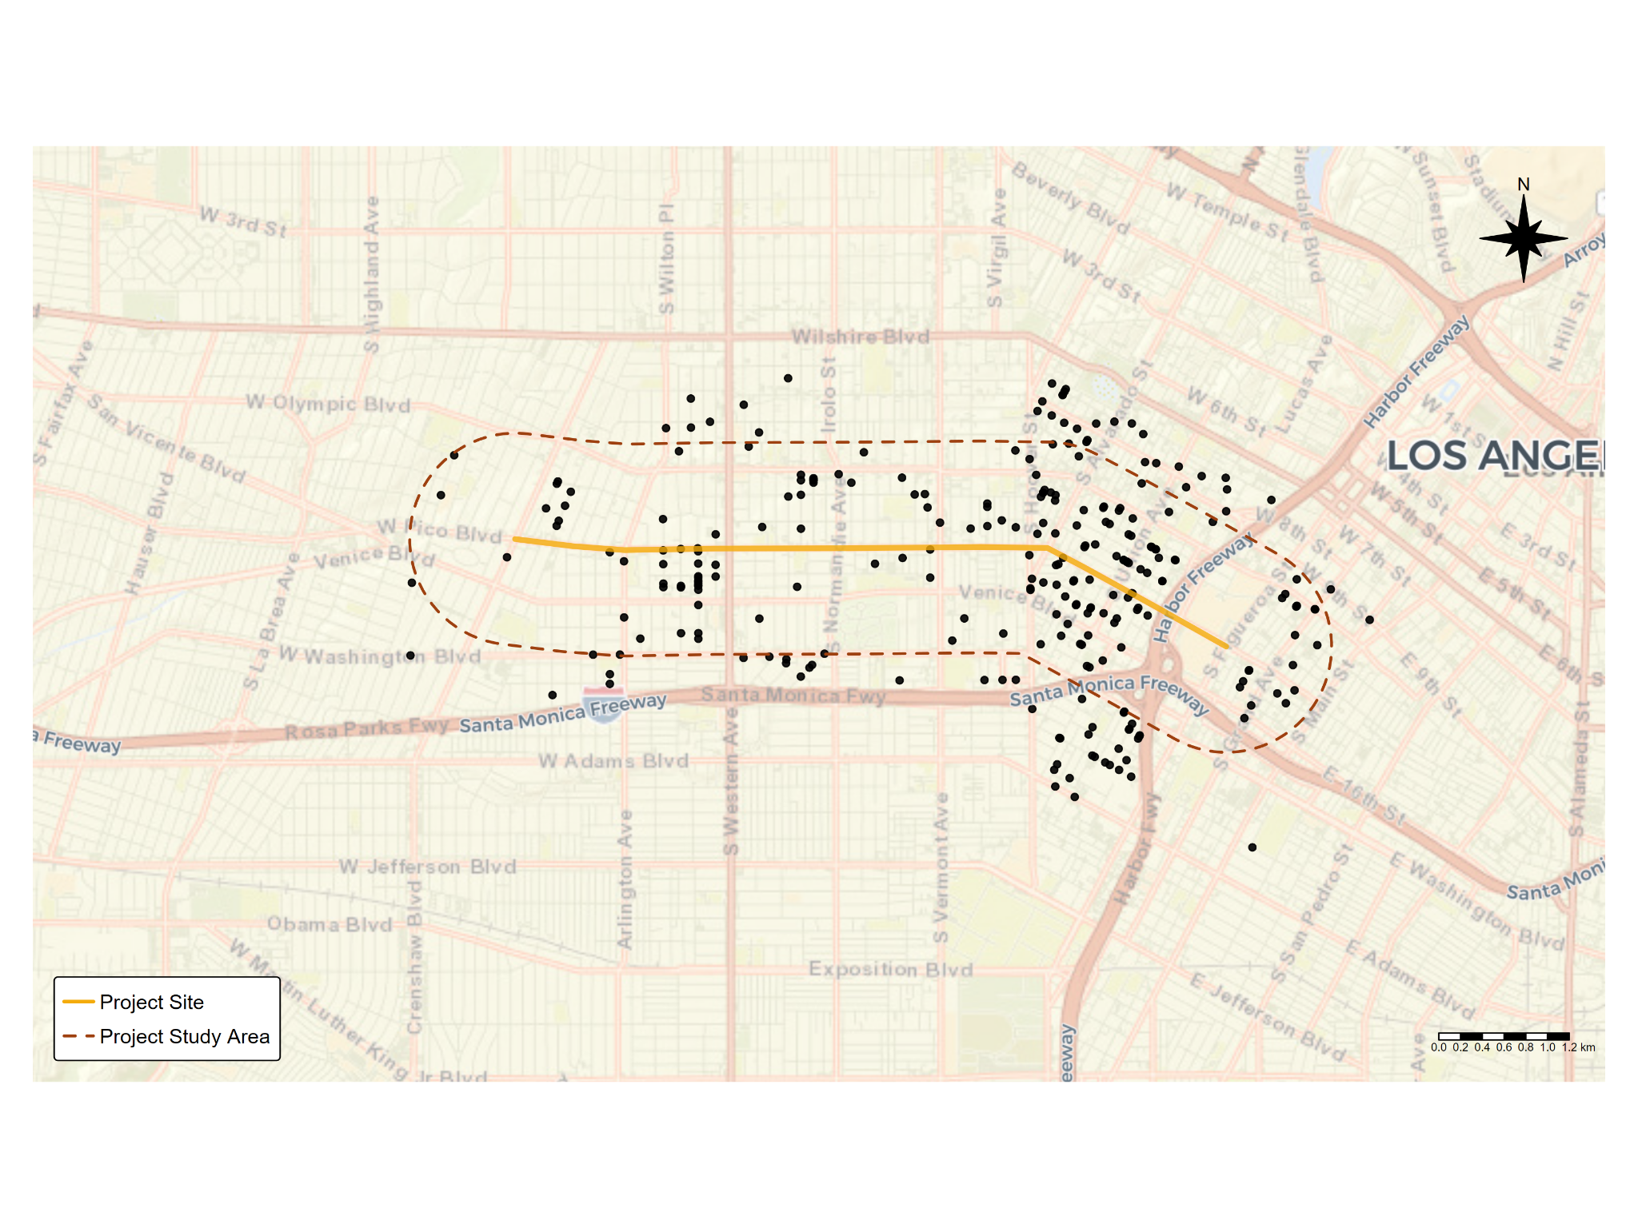

*Figure 26. Affordable Housing Developments*

*Source: Los Angeles GeoHub, Affordable Housing Development;* [*https://geohub.lacity.org/datasets/lahub::affordable-housing-development/about*](https://geohub.lacity.org/datasets/lahub::affordable-housing-development/about)*.*

## 

## 

## 

*Figure 27. Senior Housing*

*Source: Los Angeles GeoHub, Senior Housing;* [*https://geohub.lacity.org/datasets/3f842b07f7264cafa77e88305eb97e19_0/explore*](https://geohub.lacity.org/datasets/3f842b07f7264cafa77e88305eb97e19_0/explore)

## **Transportation and Commuting**

Many households in the Pico Study Area lack vehicle access. In the median census tract, about 24 percent of households do not have access to a vehicle. However, there is large variation in vehicle access, largely driven by spatial considerations. Many of the census tracts in the western area of the corridor have high vehicle access, while many on the eastern side, particularly the southeast and the northeast, have lower levels of vehicle access (Figure 28). One explanation for this may be proximity to transit. For instance, many of the census tracts with low levels of vehicle access are located near light rail stations (Pico, Westlake/MacArthur Park, Wilshire/Vermont stations), while the more car-reliant tracts are located further. In the three tracts where the majority of households lack vehicle access, light rail stations are the most accessible.

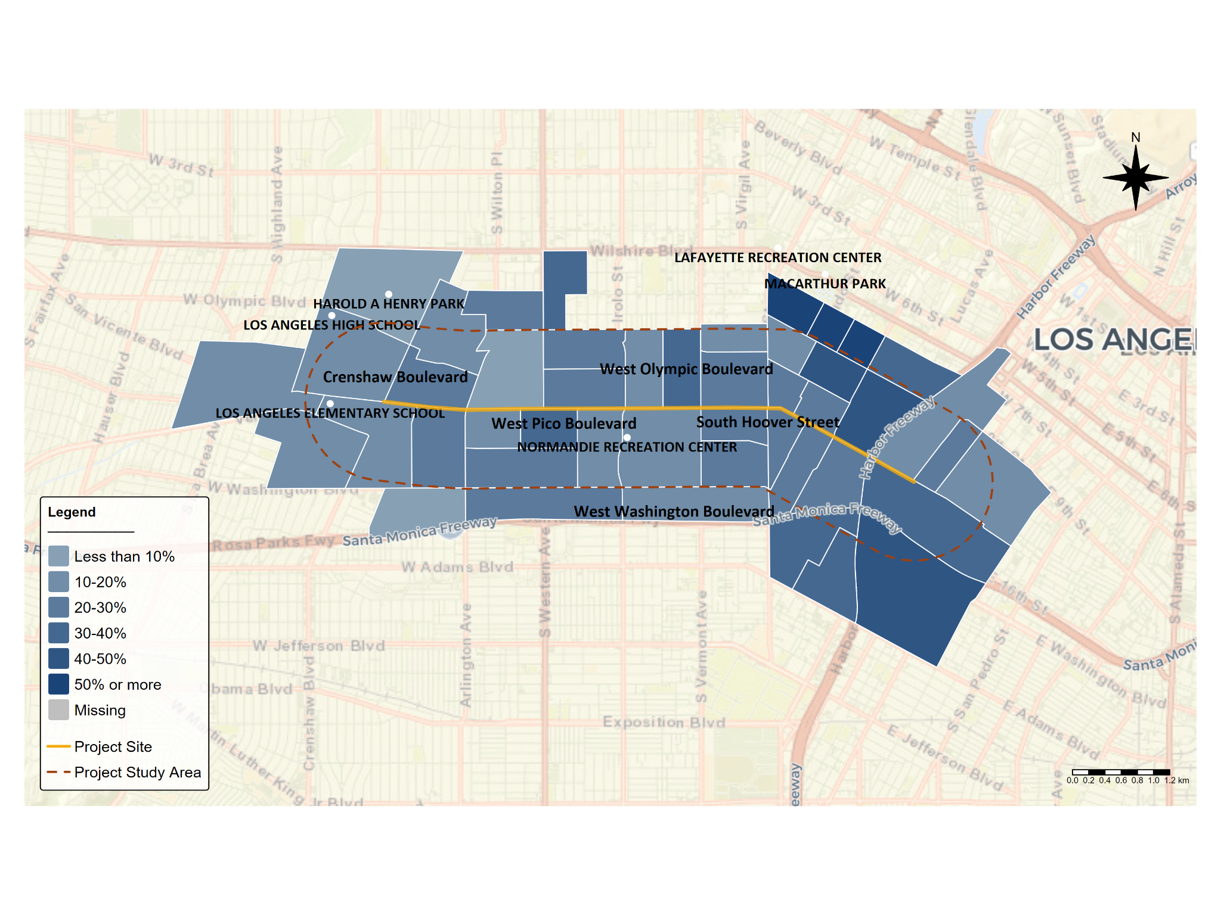

*Figure 28. Share of Households With No Vehicle Available.*

*Source: Authors’ analysis of 2019-2023 American Community Survey data table B25044, ’Tenure by Vehicles Available’.*

Most residents in the Pico Study Area use a car, van, or truck as their means of transportation to work (60 percent) although at a lower rate than the city average (Figure 29). About 18 percent of residents use public transportation (excluding taxicab)to commute and 13 percent work from home. Only 6 percent of residents walk or bike as their means of transportation to work (Figure 29). In total, approximately _____% of commuters in the Pico study area do not use a car About 67 percent of working residents have a travel time to work under 35 minutes, with most travel times to work ranging between 15 and 34 minutes (Figure 30). Approximately 14 percent of residents have a travel time to work longer than one hour, and these residents are more likely to live in the northeast portion of the corridor (Figure 31). Notably, these tracts are closer to public transit and have lower levels of car access relative to the rest of the Pico Study Area.

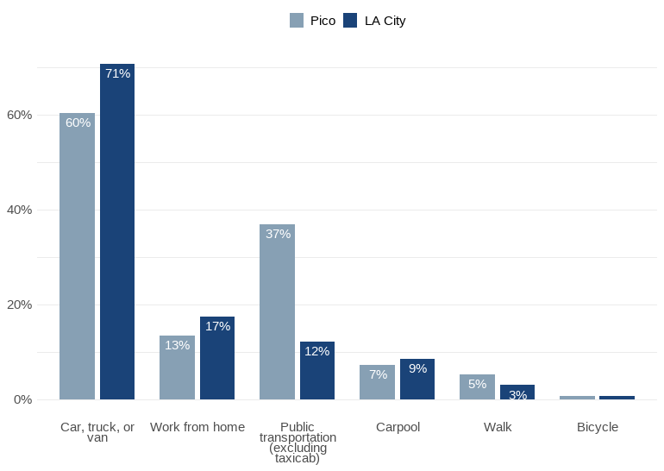

*Figure 29. Share of Pico Study Area Residents by Means of Transportation to Work*

*Source: Authors’ analysis of 2019-2023 American Community Survey data table B08301, ’Means of Transportation to Work’.*

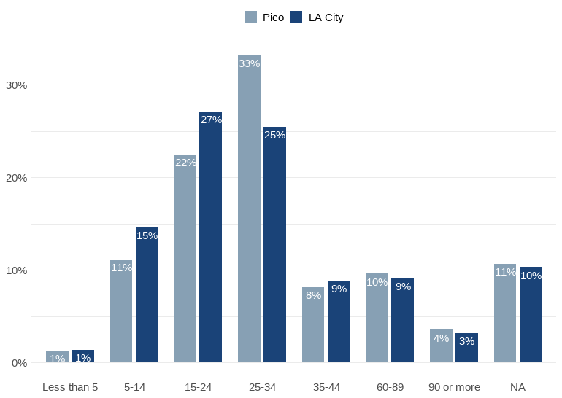

*Figure 30. Share of Pico Study Area Residents by Travel Time to Work*

*Source: Authors’ analysis of 2019-2023 American Community Survey data table B08303, ’Travel Time to Work’.*

*Notes: Percentage is based on the total population in the corridor.*

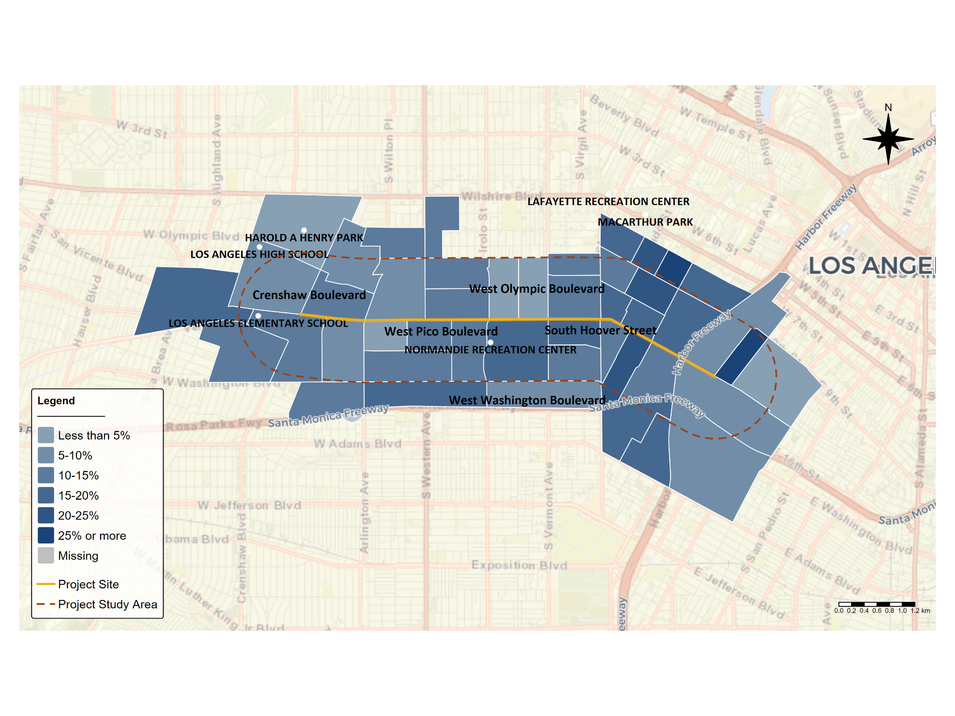

*Figure 31. Share of Pico Study Area Residents with a Travel Time to Work of 60 Minutes or More*

*Source: Authors’ analysis of 2019-2023 American Community Survey data table B08303, ’Travel Time to Work’.*

There is substantial spatial variation with respect to the percentage of household income spent on combined housing and transportation costs. Using the [H and T Affordability Index](https://htaindex.cnt.org/map/) to analyze the percentage of income spent on housing and transportation costs, we observe that housing and transportation costs in the northeast and northwest areas of the corridor are the highest (Figure 32). H+T calculates this measure for a typical household making the area median income rather than calculating how much each house spends on housing and transportation. This means that the cost burdens shown in Figure 28 below are the cost burden for a typical household in the Los Angeles region.

H and T also offers this measure for a household at the 80th percentile of area median income, which we show in Figure 30. The pattern of cost burdens remains true when observing how much a household earning 80 percent of the area median income spends, with five census tracts in which a household spends over 60 percent of income on housing and transportation alone (Figure 33).

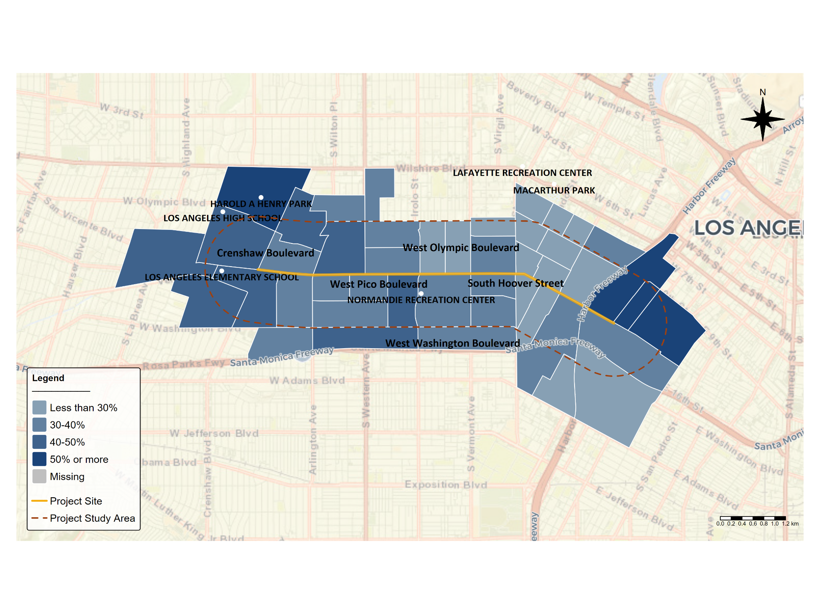

*Figure 32. Share of Income Spent on H+T Costs, Adjusted by Area Median Income*

*Source: Authors’ analysis of H+T Affordability Index, developed by the Center for Neighborhood Technology, last accessed April 30, 2025,* [*https://htaindex.cnt.org/map/.*](https://htaindex.cnt.org/map/.)

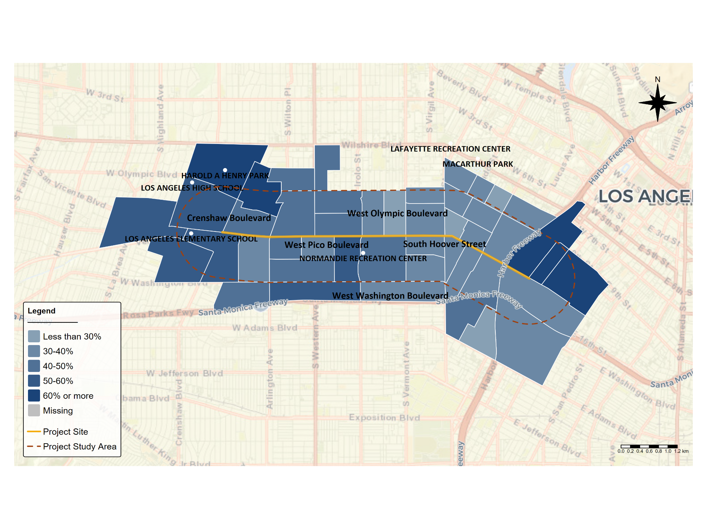

*Figure 33. Share of Income Spent on H+T Costs, Adjusted by 80th Percentile Area Median Income*

*Source: Authors’ analysis of H+T Affordability Index, developed by the Center for Neighborhood Technology, last accessed April 30, 2025,* [*https://htaindex.cnt.org/map/.*](https://htaindex.cnt.org/map/.)

According to the Transportation Injury Mapping System (TIMS), which assesses the California Statewide Integrated Traffic Records System (SWITRS), there were a total of 503 severe or fatal vehicle collisions in the Pico Study Area from January 1, 2013 to December 31, 2024. Just under half (44 percent) of these collisions involved a pedestrian, while 12 percent involved a bicycle. As highlighted in Figure 34, these crashes occurred across the corridor but are understandably.

However, there are other intersections throughout the corridor where crashes appear to be clustered, including on Vermont Avenue’s intersections with Pico Boulevard, Venice Boulevard, and Washington Boulevard. Pedestrian crashes, in particular, appear to be concentrated around the intersections between Pico and Crenshaw Boulevards and between Wilshire Boulevard and Western Avenue.

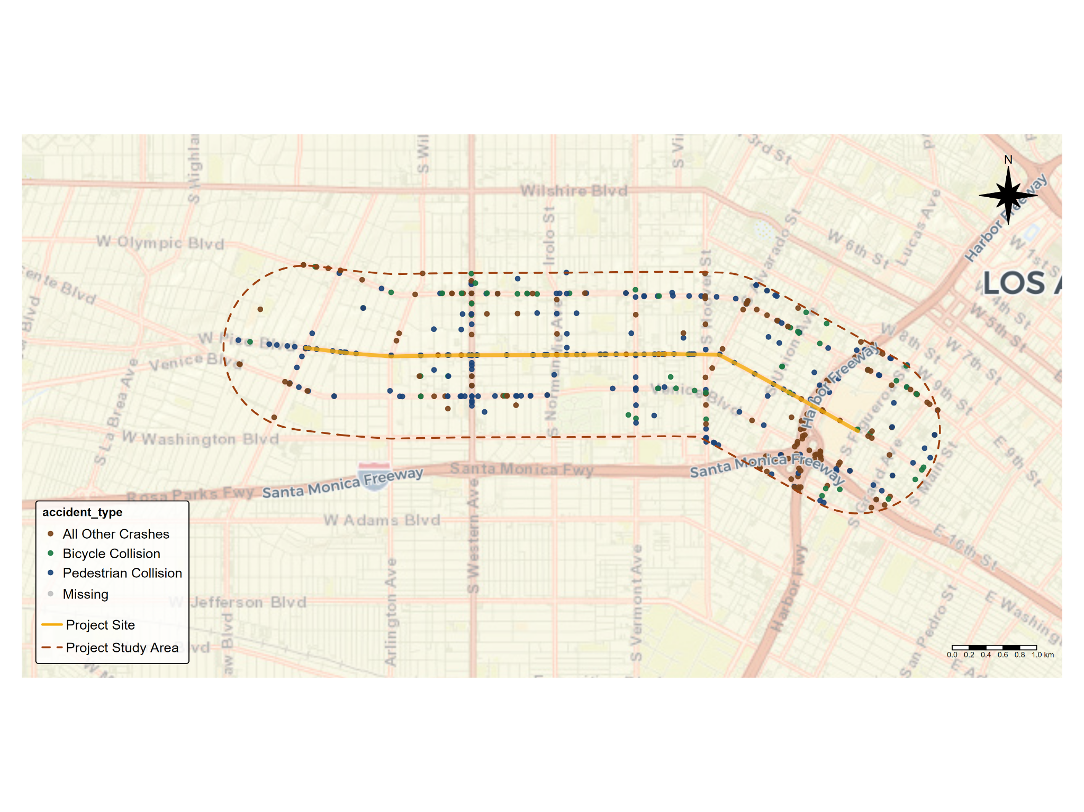

*Figure 34. Severe and Fatal Crashes along the Pico Study Area from January 1, 2013 - December 31, 2024*

*Source: Authors’ analysis of Transportation Injury Mapping System (TIMS), last accessed June 6, 2025,* [*https://tims.berkeley.edu/tools/gismap/.*](https://tims.berkeley.edu/tools/gismap/.)

## **Land use**

Finally, we examined the land use in the Pico Study Area. According to the zoning application for the City of Los Angeles, the parcels directly on Pico Boulevard in the project area are almost entirely zoned for commercial-mixed use, while the stretch of Pico Boulevard from Alvarado Street to the 110 Freeway Overpass is zoned for commercial manufacturing purposes (Figure 35).[2] However, the neighborhood within a half-mile of the corridor is primarily zoned for multi-family residential use, while the boulevards and avenues are lined with commercially-zoned properties much like Pico Boulevard. However, the western portion of the corridor, specifically west of Western Avenue, includes a number of lots zoned for single-family commercial zoning. There is a smattering of lots zoned as public facilities throughout the corridor. 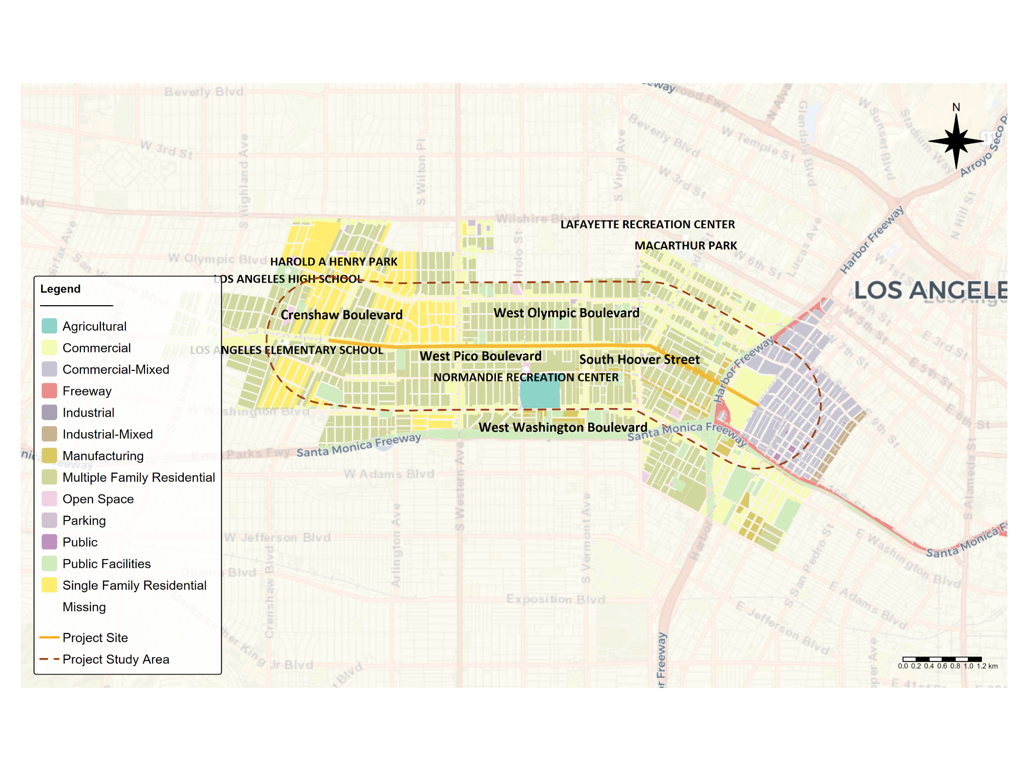

*Figure 35. Land Uses along Pico Boulevard*

*Source: Los Angeles City Planning Zoning Map, last accessed June 9, 2025,* [*https://geohub.lacity.org/datasets/lahub::zoning/explore?location=34.050726%2C-118.278655%2C14.03*](https://geohub.lacity.org/datasets/lahub::zoning/explore?location=34.050726%2C-118.278655%2C14.03)*.*

Civic Engagement and Support for HLA

In March 2024, Los Angeles voters approved Measure HLA, a citizen-sponsored mandate intended to advance the city’s Mobility Plan 2035[3]. Figure 34 depicts the precinct-level voter data in the Pico Study Area. While the majority of residents in every precinct in the corridor with available data appear to have voted in favor of the measure, some were more supportive than others with support ranging from ____ to ____ percent.

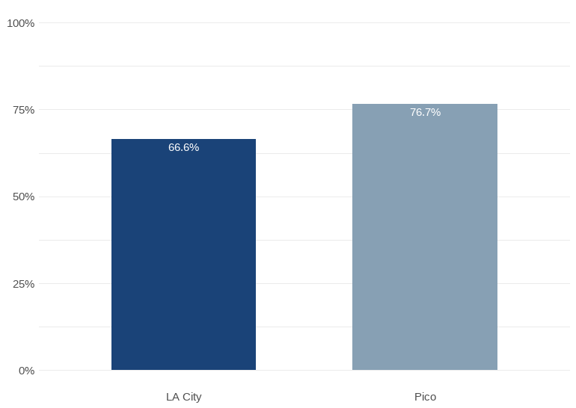

*Figure 34. Comparison of “Yes” Votes on Measure HLA: Pico Study Area vs. LA City (*LA County 2024a; LA County 2024b; LA County Clerk, 2024*).*

# Section Two: Field Observations

## **Major Stakeholders and Outreach Considerations**

*Business & Institutional Stakeholders*

* Convention Center / AEG
* LA Live / Crypto.com
* Figueroa Corridor BID
* Byzantine Latino Quarter BID

*Faith-Based Organizations*

* St. Sophia’s Cathedral
* St. Thomas Church
* Mision Evangelica del Espiritu Santo Santuarios Monte Sinai
* Iglesia Cristiana Universal

*Schools and Youth-Serving Institutions*

* Pio Pico Middle School
* Bishop Conaty High School
* Los Angeles Elementary
* Loyola High School
* Berendo Middle School
* St. Thomas School
* Equitas Charters 3 and 4
* University Value Prep Charter

*Transit & Advocacy Orgs*

* ACT-LA
* LA Walks (Promotoras Program)
* Streets for All
* National Health Foundation (promotoras for pedestrian safety)
* Koreatown Youth & Community Center
* Move LA
* LA Forward

*Other Community Partners*

* WalkGood Yard

## **Existing Infrastructure and Use Patterns**

**The project team led a**Pico Walk Audit held on the morning of May 7th f. The purpose of the walk audit was for the Community First Engagement project team to gain a deeper understanding of the street conditions and experience to inform the Pico engagement plan. The walk audit took place along a 1 mile stretch of Pico, from Bonnie Brae to Catalina St and was divided into three segments:

• Segment 1: Bonnie Brae St to Magnolia

• Segment 2: Magnolia Ave to Vermont Ave

• Segment 3: Vermont Ave to Catalina St

Walk audit participants included representative from:

While walking the segments of Pico Blvd, participants recorded their observations. The following is a summary of the observations for each segment based on the participant’s feedback.

### Segment 1: Bonnie Brae St to Magnolia Ave

Segment 1 exhibited significant pedestrian safety and accessibility challenges, including pedestrians frequently crossing midblock outside of marked crossings, faded or missing crosswalks, hazardous sidewalk conditions, and speeding vehicles. Participants also noted environmental concerns, limited parking, and heavy foot and vehicle traffic near schools, churches, and commercial areas.

***Frequent Midblock Crossings and Speeding Hazards***

Participants observed high levels of pedestrian activity and several safety and accessibility concerns. Several pedestrians and bicyclists were seen crossing Pico outside of crosswalks, particularly at the east side of Bonnie Brae where no crosswalk exists. Crosswalks at various intersections, including Magnolia, were either unmarked or faded, and some locations, such as near University Prep Value High School, had no crosswalks at all despite heavy foot traffic. Traffic was fast-moving throughout the corridor, with speeding cars observed at Bonnie Brae, Hoover, and Alvarado.

*"Older adults or people in wheelchairs can’t make it across in time — and then they’re still in the street when the light turns red."*

*"A veces los adultos mayores o personas en silla de ruedas no alcanzan a cruzar, y cuando llegan ya está en rojo.”*

*— Vendor on Pico Boulevard shares observation about transportation struggle they see frequently*

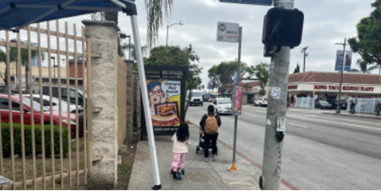Figure 1. Pedestrians walking along Pico Blvd navigating a stroller and scooter around a bus stop.

***Hazardous Sidewalks and Obstructions Impacting Accessibility***

Sidewalk conditions varied but were frequently described as hazardous, with lifted, cracked, or uneven pavement reported between Westlake and Alvarado, and again near Arapahoe and Hoover.

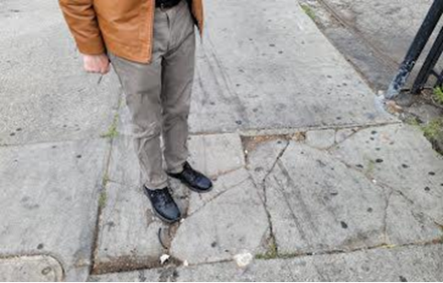Figure 2. Walk audit participant standing on cracked sidewalk.

Some sidewalks were obstructed by vendors, store displays, tables, and parked e-scooters, particularly near busy commercial spots like Ross Dress for Less and along intersections such as Westlake, Alvarado, and Hoover. Multiple locations lacked curb ramps or had missing ADA warning pads, and sidewalks were noted to be narrow or congested in several sections. Alleyways, especially those near the Salvation Army and between Arapahoe and Hoover, were flagged as areas of concern due to surface conditions and unclear pathways.

*"Sometimes [the scooters on sidewalks] come through too fast, 25 mph, and there are people walking out of stores... a kid could come out and have a bad accident."*

*"A veces pasan muy rápido, como a 25 millas por hora, y hay gente saliendo de las tiendas... un niño podría salir y tener un mal accidente."*

*— Bike shop worker*

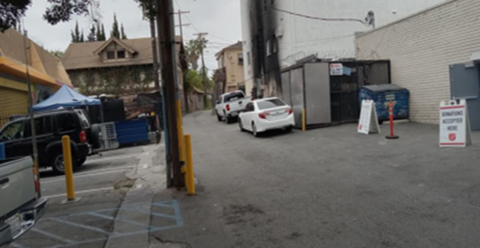Figure 3. Alleyway near Salvation Army.P

***High Vehicle and Pedestrian Traffic and Environmental Concerns***

Additional observations included high volumes of vehicle and pedestrian traffic around Ross Dress for Less and nearby churches, crowded bus stops, and active school drop-off and pick-up areas near 1929 Pico. Participants also noted environmental concerns such as street noise, visible trash, poor air quality, and a large curb radius at Westlake making pedestrian crossings feel exposed. Trees were reported as overgrown in some areas, with cracked sidewalks nearby and empty tree wells present. Parking was described as limited and difficult to find, with multiple comments pointing to competition for space near community destinations.

### Segment 2: Magnolia Ave to Vermont Ave

Segment 2 was marked by numerous pedestrian safety issues, including cracked and uneven sidewalks, obstructions from vendor setups and encampments, and a lack of ADA-compliant features. Participants also observed malfunctioning traffic signals, abandoned EV charging stations, and high vehicle speeds, leading to discomfort and unsafe conditions for pedestrians, despite some infrastructure improvements like bike parking and street cleaning efforts.

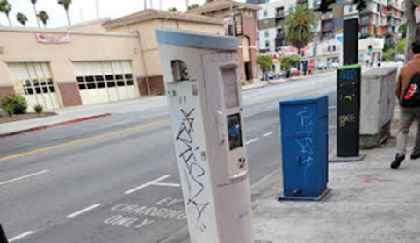Figure 4. Abandoned EV charging station.

***Sidewalk Hazards and Obstructions Affect Pedestrian Movement***

Throughout Segment 2, from Magnolia Avenue to Vermont Avenue, participants reported a wide range of physical and environmental conditions impacting pedestrian comfort and safety. Sidewalk hazards were common, with lifted and cracked pavement noted in multiple locations including between Westmoreland and Elden, at Menlo, Orchard, and from Vermont to Menlo. Several areas lacked ADA-compliant features, such as curb ramps—especially at the southeast corner of Westmoreland—and there were repeated mentions of narrow sidewalks not accommodating two-way pedestrian flow. Sidewalks were also blocked by bulky furniture, carts, large vendor setups, and personal belongings from encampments, notably near Menlo Avenue and the post office at Westmoreland. These obstructions, combined with high pedestrian volumes (including people carrying laundry, using wheelchairs, or pushing strollers), often forced individuals to walk close to or in the street. The laundromat, Pico 2 Coin Laundry, at Menlo was a frequent point of use, and many were observed pushing their laundry carts along Pico.

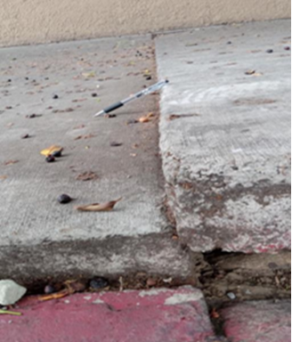

Figure 5. Lifted sidewalk with pen for scale, highlighting surface hazards.

***Non-Functional Traffic Infrastructure and Dangerous Intersections***

The corridor included a mix of active uses such as a busy laundromat, gas station, car wash, abandoned EV charging stations, and street vendors selling food and household items. A large encampment was noted near Menlo, and the area between Westmoreland and Pico had a heavy presence of scooters, carts, and dockless bikes, some abandoned on the sidewalks. Participants observed non-functioning pedestrian and traffic signals. These included a red hand signal that was not working on the northbound east side at Westmoreland, a pedestrian signal was stuck on the walking man icon, and a non-operational speed feedback sign near Vermont. The intersection at Vermont and Pico was described as very busy, with fast-moving traffic in all directions. One person witnessed a car running a red light and making a left turn at Westmoreland. Alleyways were mentioned as sites for vehicle turning and U-turns, raising safety concerns. Observations indicated the presence of potholes, uneven streets, and overgrown tree roots, particularly around Magnolia and between Vermont and Menlo. The intersection of Pico and Westmoreland was flagged for poor curb ramp design and crosswalk placement, which contributed to pedestrian exposure and discomfort when crossing. Several noted that people crossing the street had very limited space, as vehicles passed very closely.

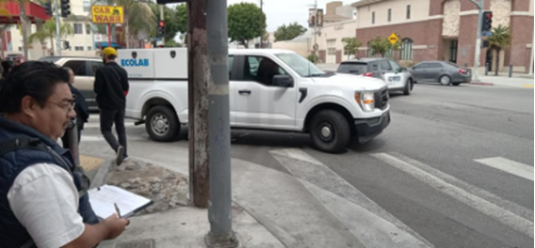Figure 6. Southeast corner of Pico and Westmoreland.

***Moderate Comfort Levels Despite Infrastructure Improvements and City Services***

Although some public amenities like designated bike parking, parking meters, and EV stations were present, the environment was described as only moderately comfortable, with overall ratings ranging from 5/10 to 8/10. The mixed impressions were attributed to street cleaning efforts possibly tied to a Business Improvement District (BID) and a visible city infrastructure presence, Segment 3: Vermont Ave to Catalina St

In Segment 3, participants reported significant pedestrian discomfort due to cracked sidewalks, obstructions, and poor street conditions. Although public transit infrastructure was present, the area was described as moderately comfortable, with challenges like inadequate lighting, unsafe intersections, and fast-moving traffic compromising pedestrian safety and convenience.

***Pedestrian Comfort Compromised by Sidewalk Damage and Obstructions***

In Segment 3, from Vermont Avenue to Catalina Street, participants observed continued issues with pedestrian infrastructure and general street conditions. Sidewalks were frequently lifted, cracked, or broken, particularly between Vermont and New Hampshire, presenting hazards for pedestrians and wheelchair users. The sidewalks were also described as narrow and cluttered, with vendors, bulky items, and boxes from local businesses, such as a furniture store near Berendo, taking up walkway space. Many pedestrians were present in this segment, but the sidewalk width often did not accommodate the foot traffic comfortably.

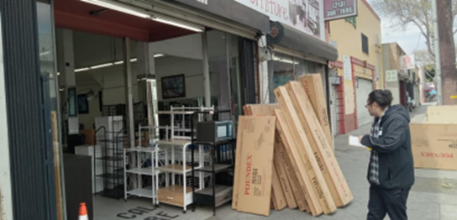Figure 7. Businesses use sidewalks to display wares and for loading inventory purposes***Street Conditions, Poor Lighting, and Unsafe Intersections***

Several locations had potholes, uneven street surfaces, and cracked asphalt, especially near Catalina and between Vermont and New Hampshire. Street lighting was reported as poor, with one open electrical box noted and concerns about the area being very dark at night. Observers mentioned wire theft from utility infrastructure, and damaged or exposed electrical fixtures, including at a nearby fire station. Crosswalks were faded or in poor condition, particularly at the Vermont intersection, and one speed feedback sign near Vermont was not functioning. There were also complaints about not having enough time for pedestrians to cross at intersections like Catalina.

***Public Transit Infrastructure and Overall Comfort***

Traffic observations included fast-moving cars and instances of unsafe vehicle behavior, including drivers going straight through intersections from incorrect lanes at New Hampshire. Scooters and skateboards were seen riding on sidewalks, adding to congestion and safety concerns. Despite some areas feeling slightly wider—particularly between Catalina and Berendo—the overall pedestrian environment was limited by sidewalk quality, lighting issues, and vehicle behavior. Public transit infrastructure such as Metro’s 754 Rapid Line and several bus stops were present, though some were noted as needing general improvement. Participants described the segment as moderately comfortable but marked by several physical and environmental challenges. P

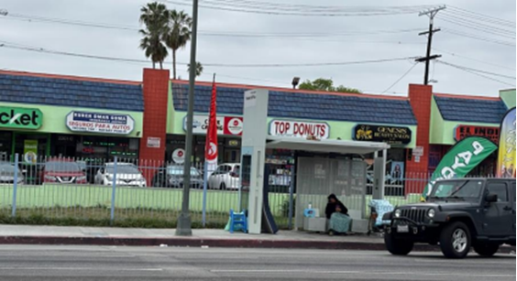Figure 8. Presence of public transit infrastructure.

### Summary

The Pico Walk Audit, conducted in three segments from Bonnie Brae Street to Catalina Street, revealed consistent issues affecting pedestrian and cyclist safety, accessibility, and comfort. Participants across all segments reported damaged or uneven sidewalks, faded or missing crosswalks, and frequent obstructions from vendors, bulky items, and encampments, making navigation difficult—especially for people using mobility devices. Bicyclists were often seen riding on sidewalks or against traffic due to a lack of dedicated bike infrastructure, and scooters and dockless bikes frequently blocked pedestrian paths. Speeding was a major concern throughout the corridor, with multiple reports of fast-moving vehicles and unsafe driver behavior at intersections. Poor lighting, non-functioning pedestrian signals, and exposed electrical fixtures added to the safety risks. While some amenities like bus stops, bike parking, and EV charging stations were present, the chargers appeared abandoned and underused. Overall, conditions were described as only moderately comfortable due to persistent issues with traffic behavior, sidewalk congestion, and inadequate space for both walking and biking.

## **Observations from Project and Engagement Team**

## On May 7, 2025, the KDI and LADOT team walked along Pico Boulevard from 9:30 AM to 11:00 AM, covering the stretch between S. Hoover St. and Arapahoe St,gathering personal stories from residents to better understand insights that are often missed through other engagement methods. The conversations focused on the main challenges residents face, their ideas for transforming the street to benefit everyone, and how they would like to be engaged throughout the project.

### Means of Transportation and Pedestrian Safety

From the [insert number] community members that KDI and LADOT spoke with on Pico Boulevard indicated that they regularly walk, bike, and use the bus. Many residents shared that they rely on public transit and walking as their primary mode of transportation, consistent with census data analyzed by the project team indicating higher than average transit and walking for commuting purposes. However, individuals frequently expressed concerns that unsafe alleyways, aggressive drivers, and areas lacking adequate lighting create dangerous conditions for pedestrians. Similarly, residents cited safety concerns resulting from sidewalk conflict between on-foot pedestrians and fast-moving scooters and bikes. In addition, some individuals expressed that they felt a lack of personal safety when walking in sight of visible homelessness, and reports of graffiti, trash, and sidewalk obstructions affect the sense of comfort and dignity in public spaces.

Pedestrian burdens are often distributed unevenly across groups. For instance, older adults, women with children, and individuals with disabilities the project team spoke with emphasized how short pedestrian signal cycles create difficulties crossing the street and navigating Pico Boulevard since these users might not be able to walk at the brisk pace the traffic signal assumes is sufficient to get across the street. Additionally,general pedestrian safety issues such as inadequate lighting, a lack of (safe?) crosswalks, and unsafe and unpleasant interactions with cars are greater for these groups.

### Informing Residents of Projects

Most residents indicated that they are unaware of city projects unless they receive flyers or hear from others directly. They expressed a preference for outreach via flyers, posters, and local news as opposed to internet-based updates. They also noted the importance of communicating with images and other visuals to surmount language and literacy barriers. Specifically, local business owners suggested putting posters in stores and on posts to reach those “in their own world”.

*"I think the best thing [to engage and inform] is the way they are doing it now — talking to people. Flyers or posters? We take them and don’t read them."*

*"Creo que lo mejor es como lo están haciendo ahora — hablando con la gente. Volantes o carteles los tomamos pero no los leemos.”*

*— Scooter rider*

### Suggestions From Residents to Improve Pedestrian Safety

Suggestions from the community about how to improve pedestrian were far-reaching though some common themes emerged with some solutions more straight-forward than others. A recurring concern across interviews was that poor nighttime visibility leads to feelings of insecurity, and residents accordingly requested increased lighting. When asked about preference in bike lane design, the people the project team spoke with on Pico also strongly supported protected bike lanes, as painted lines are not seen as sufficient for safety due to frequent vehicle incursions and disrespect for cyclists’ space. Several residents mentioned the need to repave streets, as frequent potholes and broken pavement are dangerous for cyclists. Community members also expressed a need to increase pedestrian safety on the sidewalk. They emphasized that scooters and e-bikes use sidewalks aggressively and sometimes cause accidents, necessitating designated zones or greater enforcement. They also indicated a need for more clearly marked, visible pedestrian crossings, especially near schools and intersections like Bonnie Brae & Pico. Some individuals have a positive view of biking, particularly for mobility and health, and expressed interest in improving the cyclist experience to encourage mode shift.

## **Story Collection**

## 

The project team conducted twelve intercept interviews with community members along Pico Boulevard. The conversations focused on the main challenges residents face, their ideas for transforming the street to benefit everyone, and how they would like to be engaged throughout the project.

**Interview Findings**

The community members the project team interviewed primarily rely on walking, biking, and public transit for transportation. However, many face significant safety concerns, including aggressive drivers, speeding cars, poorly lit areas, and unsafe alleyways. Sidewalk conflicts between pedestrians and fast-moving scooters or bikes are common, and homelessness adds to unease about personal safety when sidewalk space and comfortable street crossing opportunities are limited. Older adults and individuals with disabilities struggle with short pedestrian signal times, making designated crossings that are available difficult to navigate with little room for error for these slower moving and more vulnerable pedestrians. Additionally, many residents are unaware of local projects unless informed through flyers, posters, or direct word of mouth, indicating a need for better outreach. Preferred communication methods include visual materials for those who cannot read, local news, and posters in businesses, as digital updates are less effective. Business owners recommend displaying notices in stores to ensure broader community engagement. These insights highlight both transportation challenges and the importance of accessible, in-person communication strategies.

**Memorable Quotes**







# **Section 3: Key Recommendations**

This section presents recommendations informed by the findings in Sections 1 and 2 regarding the needs of community members in the project area to support their full participation in engagement efforts. By analyzing the intersections of age, race/ethnicity, income, disability status, housing insecurity, transportation needs, and existing behaviors, our team has identified priority populations and best practices for LADOT’s engagement initiatives to maximize reach in a context relevant to the Pico study area. This data-guided approach is designed to help LADOT allocate resources strategically and concentrate efforts on communities that are poised to benefit most from the projects.

## **Outreach Strategy Recommendations Based on Demographics**

### Language Access

Since a large number of residents in the Pico Study Area speak languages other than English, engagement efforts should be multilingual to ensure broad accessibility and inclusivity. Outreach materials should be provided in both English and Spanish at a minimum, recognizing that while many residents may speak some English, a significant portion are either not fluent or do not speak English at all. To maximize comprehension, English-language materials should be written and translated in plain, straightforward language that can be easily understood by people with limited or non-technical vocabulary In addition to Spanish, the project team recommends including Korean-language materials as a standard component of outreach efforts will increase inclusion. Some attention should be given to Chinese and Tagalog-speaking populations as well, although these groups are smaller in size compared to the Spanish- and Korean-speaking communities.

Geographic differences within the corridor further suggest that outreach strategies should be tailored by location. In the eastern portion of the Pico Study Area, where Spanish-speaking households are particularly concentrated, engagement should emphasize Spanish-language communication. In contrast, the western portion of the corridor, which features a higher proportion of households speaking Asian or Pacific Island languages, should prioritize Korean-language materials, with supplementary resources available in Chinese and Tagalog where appropriate.

Ideally, street teams conducting in-person outreach should reflect the linguistic diversity of the community. Bilingual Spanish-speaking and Korean-speaking staff would strengthen effectiveness, and additional capacity in Chinese and Tagalog will even further improve outreach efforts. These teams should also be equipped with localized information about language concentrations to better target their engagement efforts within specific tracts.

Partnerships with trusted community-based organizations, faith-based institutions, and local businesses will be critical for reaching immigrant and non-English-speaking communities. Collaborating with cultural centers and ethnic media outlets—such as Spanish-language newspapers, Korean radio stations, and community newsletters—will help disseminate information more broadly and credibly.

Furthermore, translation and interpretation services should be built into all public meetings, workshops, and events. Live Spanish and Korean interpretation should be offered, and Chinese and Tagalog interpreters should be available on-call as needed. All critical materials, including flyers, project updates, and surveys, should be translated into the relevant languages at each phase of engagement.

Finally, messaging should be culturally relevant, recognizing the distinct experiences and values of the corridor’s Mexican, Salvadoran, Guatemalan, Korean, Chinese, and Filipino communities. Communications should be crafted not just for language access, but also for cultural resonance, to build trust and encourage meaningful participation.

### Digital Access

To ensure equitable and inclusive community engagement Pico Study Area, outreach efforts must acknowledge and address the significant disparities in access to broadband and digital devices. Given that some census tracts in the eastern portion of the Pico Study Area have over 30% of households without internet access and over 10% without any device, community engagement strategies must not rely solely on digital tools such as websites, email, or social media.

The project team recommends the following measures to bridge the uneven access to internet and desktop computers:

* Printed flyers, mailers, and posters in multiple languages,
* In-person outreach via community canvassers, neighborhood meetings, or events,
* Telephone-based engagement, which can be accessed from landlines or cell phones.[4]

Digital strategies should also be adapted to reflect smartphone-only access. Engagement tools must be mobile-friendly, low-bandwidth, and accessible without requiring large file downloads or desktop interfaces. Text message surveys, mobile-optimized websites, and simple online forms can help ensure wider participation. Where feasible, public Wi-Fi access points, device loan programs, and digital literacy support should be offered to bridge access gaps.

### Disability Status

Residents with disabilities make up approximately 11 percent of the Pico area population. While this rate aligns with the countywide average, residents with disabilities are not uniformly distributed across the corridor and their unique needs can vary. They tend to be concentrated in certain census tracts, particularly in the western, northeastern, and southeastern areas. In some of these tracts, more than 15 percent of the population has a disability, and there are nine tracts where over 500 individuals are affected.

Patterns of disability also vary by type. For example, while the median tract has 65 residents with a vision difficulty, some tracts in the eastern part of the corridor have over 150 individuals with a vision impairment. A similar trend exists for individuals with hearing difficulties: although most tracts have fewer than 3 percent of residents with hearing impairments, a small group of tracts contain more than 100 such individuals, with one tract having 256. Ambulatory difficulty is more evenly distributed but still shows higher concentrations in the same regions—western, northeastern, and southeastern Pico Boulevard.

In response to these patterns, community engagement efforts should be tailored to ensure accessibility for people with a wide range of disabilities and to focus outreach efforts in areas with higher concentrations of disabled residents. Specifically:

* Engagement materials and events should strive to meet or exceed accessibility standards, including offering where applicable- large-print materials, Braille, ASL interpretation, captioning, and audio formats as appropriate. Visual materials should follow best practices for contrast and font readability, such as providing the right amount of space between lines of text, using clean typography, avoiding using all caps, not underlining text, and choosing a color scheme that provides high contrast between the text and the background[5].
* In-person engagement should occur at fully accessible locations and include mobility accommodations such as ramps, elevators, and accessible seating. Advanced notice should be given for accommodations, and transportation assistance may be needed for residents with limited mobility.
* Targeted outreach in the census tracts with the highest concentrations of residents with disabilities can help ensure these individuals are aware of and can participate in engagement opportunities. This could include working with disability service providers, independent living centers, and healthcare providers who serve these areas.
* Community engagement timelines should allow for additional flexibility, recognizing that scheduling transportation, caregivers, or communication support can require extra time for individuals with disabilities.
* Engagement design should be inclusive from the start, not as an afterthought. Engaging individuals with disabilities in the co-design and planning of outreach strategies can help identify and eliminate barriers before they arise.
* Collaborate with disability advocacy groups that represent people with disabilities (Brangman 2022).

### Age

The dominant age group within the Pico Study Area is between 30 and 44, the age cut points in the census that most closely align with the Millennial generation, with the other age categories having similar percentages of residents in them. Based on this distribution, we recommend focusing on the following outreach strategies, **with a particular emphasis on those targeted at Millennials:**

To reach youth (0–18, includes Gen Z and Alpha):

* Include activities for youth at events to engage both children and their parents.
* Use creative media: Engage youth through art, music, and digital media to foster connection  
  (Mirza et al., 2014).
* Gamify engagement: Incorporate game-like features and interactive tools to sustain attention (Lightbody, 2020).
* Leverage peer networks: Partner with youth organizations, schools, and colleges to engage young people through trusted social channels (Lightbody, 2020).
* Incentivize participation: Offer vouchers, event tickets, or discounts to motivate involvement (Lightbody, 2020).

To reach young adults (18–29, includes Gen Z):

* Embrace entertainment-based marketing: Use entertaining content tailored to current media trends and human-centered storytelling.[6]
* Prioritize the right platforms: Focus engagement on YouTube and Instagram, which are the most used platforms by this age group, but also conduct engagement on Facebook, Snapchat, and TikTok, since a large percent of people in this age group are also on those platforms.[7]

**To reach adults aged 30–44 (Millennials):**

* **Maintain a strong online presence: Create up-to-date profiles on major social networks and promote key information online.[8]**
* **Use real, relatable stories: Feature authentic stories from everyday people to foster empathy and connection.[9]**
* **Target major platforms: Focus on YouTube and Facebook, followed by Instagram.[10]**

To reach Gen X (ages 45–59):

* Focus on video and social platforms: YouTube is the primary platform used by this age group, followed by Facebook.[11]
* Use testimonials: Gen Xers like to know other people have already had positive experiences with engagement activities, and outreach materials that showcase everyday life and real-world situations will be most effective for this group.[12]

To reach Baby Boomers and older adults (60+):

* Recognize online presence: Many in this group use social media—63% use it to connect with loved ones, and they spend more time online than some younger cohorts.[13]
* Use trusted platforms: Focus on Facebook and Twitter; Instagram and Snapchat are less effective.[14]
* Combat skepticism: Ensure online messages are trustworthy and clear to overcome concerns about digital marketing.[15]
* Adapt communication methods: Use phone calls, in-person meetings, and printed materials to suit common preferences (Brangman, 2022).
* Use face-to-face outreach: Conduct personal outreach at familiar locations like senior centers or homes (Lightbody, 2020).
* Incorporate health-related content: Offer health incentives or resources to boost participation (Lightbody, 2020).
* Provide logistical support: Help with transportation or caregiving needs to make participation easier (Lightbody, 2020).
* Primary platforms: YouTube and Facebook are most widely used; 41% of those 65+ use Facebook.[16]

### Race/Ethnicity

The Pico Study Area boundaries include a significant population of people who are Hispanic/Latino and Asian. As such, the engagement team should take special care to conduct engagement in a way that acknowledges the historical context and attempts to build trust. Exploring and acknowledging prior municipal actions that harmed this community, such as Urban Renewal or transit projects that displaced people, is imperative for building a long-term engagement strategy that attempts to rebuild trust with the community.

In addition, since 48% percent of the population are immigrants, all outreach materials should protect the confidentiality of participants, and this confidentiality should be reminded to participants at each point in the engagement. For instance, survey materials should be conducted through secure platforms and information about a person’s race and ethnicity should never be stored alongside their name or other personally identifying information. This is particularly critical for immigrant communities that may fear legal repercussions or deportation (Brangman 2022).

Other tactics that the engagement team can take to increase the participation and comfort of immigrants in engagement activities include:

* Offering to walk participants to and from their cars
* Employing outreach workers or cultural brokers who share the same background as the target population to overcome cultural barriers and establish trust (Lightbody 2020).
* Holding community events in spaces where immigrant populations already gather, such as cultural centers, places of worship, or ethnic community groups (Lightbody 2020).

### Family Structure

Since roughly 12,000 households in the Pico Study Area include children under the age of 18, considering family needs during outreach and engagement activities is imperative. And, since almost half of these families with children are led by single parents, offering childcare at events is of utmost importance. Organizing family centric events can also be useful, since it allows parents and kids to connect with the engagement effort while also spending quality time together.[17]

### Other Considerations

With each of these groups, including community members in designing outreach strategies—and actively seeking their input and feedback throughout the process—can help ensure that engagement efforts are accessible and inclusive of all residents.

Additionally, building long term trust with communities, particularly those harmed by past policies or practices, requires entering early to listen to residents’ needs before proposing solutions. Too often, engagement occurs only after key decisions have been made, resulting in solutions that may not reflect community priorities or, worse, may cause unintended harm. Listening early on to the needs of residents and including them in decision making is key to increasing equity (Stacy et al. 2022). Equally important is closing the loop: after decisions are made, it is critical to report back to community members and explain how their input influenced the outcome.

The engagement team should also continuously monitor key metrics throughout the process and adjust strategies accordingly. For example, in a community where 57 percent of residents identify as Hispanic or Latino and 21 percent of residents identify as Asian, as is the case in the Pico Corridor, outreach efforts should aim to ensure that approximately 57 and 21 percent of participants, respectively in engagement activities and survey responses, reflect those demographics. If engagement is not representative of the constituency, the team should revise its strategies to better reach underrepresented groups using the tools described above. Residents engaged in outreach efforts should similarly reflect the share of renters (87%) and homeowners (13%) and the share of residents living below the federal poverty line (24%).

Additional best practices for equitable community engagement—adapted from Stacy et al. (2023)—are outlined in the accompanying box.

Box 1

**Best Practices for Equitable Community Engagement**

To foster equitable and effective community engagement, cities should invest in deep engagement early in the process and continue throughout implementation. Key strategies include:

* **Center historically excluded voices:** Prioritize engagement with people with low incomes, people of color, and others historically left out of decision making by hosting events in familiar community spaces or partnering with trusted grassroots organizations. Hire local residents for outreach.
* **Offer multiple participation options:** Provide both in-person and virtual engagement opportunities, including small-group discussions tailored to specific language or cultural needs, to ensure accessibility and comfort for all participants.
* **Compensate and support participants:** When feasible, pay community members—especially those in leadership roles—for their time. Offer supports such as childcare, transportation vouchers, and food to remove participation barriers.
* **Maintain transparency and follow up:** Share decisions, next steps, and how community input was used to build trust and demonstrate accountability.
* **Track progress on inclusion:** Monitor engagement demographics in real time and solicit feedback through focus groups to identify gaps and opportunities for improvement.

Source: Adapted from Stacy, Christina Plerhoples, Leah Hendey, Steven Brown, and Kathryn L.S. Pettit. *Disrupting Structural Racism: A Research Agenda for Advancing Equitable Housing Outcomes.* Washington, DC: Urban Institute, 2023. <https://www.urban.org/research/publication/disrupting-structural-racism>

# References

Brangman, S. A. (2022). Achieving diversity in study populations: The importance of community engagement. National Institutes of Health, 1(1), 1-10. <https://pmc.ncbi.nlm.nih.gov/articles/PMC9669248/pdf/nihms-1835212.pdf>

Einstein, Katherine Levine, David M. Glick, Maxwell Palmer. Neighborhood Defenders: Participatory Politics and America’s Housing Crisis. Cambridge University Press; 2019.

Eskew, R., Dumez, C., & Ripple, B. (2014). Community engagement toolkit: Engaging people in planning and design. Wyandotte County Health Department. Retrieved from <https://www.wycohealth.com/wp-content/uploads/2014/05/EDR-Toolkit-Present.pdf>

Lightbody, R. (2020). ‘Hard to reach’ or ‘easy to ignore’? Promoting equality in community engagement. Glasgow Caledonian University. Retrieved from <https://researchonline.gcu.ac.uk/files/27037627/WWSHardToReachOrEasyToIgnoreEvidenceReview.pdf>

Mirza, Raïsa, Vodden, Kelly, & Collins, Gail. (2014). Developing innovative approaches for community engagement. Memorial University of Newfoundland. Retrieved from <https://d1wqtxts1xzle7.cloudfront.net/35845021/community_engagement-libre.pdf>

Stacy, Christina, Karolina Ramos, Donovan Harvey, Sonia Torres Rodríguez, Jorge Morales-Burnett, and Sabina Morris. 2022. “Disrupting Structural Racism Increasing Transportation Equity in South Dallas.” Urban Institute. <https://www.urban.org/sites/default/files/202212/Disrupting%20Structural%20Racism.pdf>

# Notes

# Appendix 1 - Story Collection Transcripts

### [Edgar Cuautle - 99 Cents store owner]

﻿

Speaker 1 (00:01)

Again, uh, so, how do you usually get around Pico Boulevard, or what brings you here?

Speaker 2 (00:06)

Well, I have the business here that I usually are.

Speaker 1 (00:10)

Are there specific spots that feel safe, unsafe or difficult to navigate?

Speaker 2 (00:15)

I'm safe, right?

Speaker 1 (00:17)

Safe unsafe or difficult to navigate.

Speaker 2 (00:19)

Officially, the main personally originally safe the other end of traffic world. Are sweetie, but like, uh, I would say it would probably be like those other students, I think

Speaker 1 (00:33)

Oh, right.

Speaker 2 (00:33)

Yeah, that's take over alleyway, like almost a reality way here in your season.

Speaker 1 (00:38)

Oh okay, correct. Yeah, alright, uh, what what role does the street play for you in your everyday life?

Speaker 2 (00:44)

So I mean, it's my business for UP in a set of business. It's like the community like here, I got all every customer will be Good night, I'll tell you before and we obviously AI. We can learn a more contested area where more we have like a sensitive It's like other parts of La that are really horrible.

Speaker 1 (01:07)

Um, cool, um, if you could change one thing about Pico, what would it be?

Speaker 2 (01:14)

I think we'll be good to get at more bike lanes, because like I know there's one on Venice, a little more and even though it I feel Venice isn't as active as people. Okay, at least like, you know, dedicated bike players.

Speaker 1 (01:31)

Yeah, um, what's the best way for you to stay informed or involved in these kinds of projects?

Speaker 2 (01:36)

Uh, honestly, I don't even know what's the things I get up for like people walking around, really, like he'll give me flyers, and then I suppose off. Or yeah, and let people know, because I mean, every once in a while, there's like some of men, oh, it's going to benefit me about, you know, I constantly good, I like that. Iron ore organizations.

Speaker 2 (01:59)

I mean, II would like that, have more attention to That's going on with

Speaker 1 (02:06)

Right? Okay. And then these a couple questions are specific for Pico boulevard, isn't it?

Speaker 1 (02:12)

The city's exploring new bike lane designs, some protected, and some painted yeah, what would make Viking feel safer for you or more appealing for you in the boulevard time?

Speaker 2 (02:22)

I feel they have to improved perspective. There is so much like spinning cars and apart, and others like a lot of it's generally bad driving like I have a camera facing the okay, because I can't record. I won't car crash everything.

Speaker 1 (02:42)

All right. Oh, what's the week?

Speaker 2 (02:46)

II set out mostly for the people because you know, people are like, oh dear.

Speaker 1 (02:49)

I'm recording that, say

Speaker 2 (02:50)

I don't know I didn't have before for now. I'm like, oh yeah, I'll send me this.

Speaker 1 (02:54)

Right? Okay, cool, um, these changes are happening nearby, like the convention center expansion. How do you think these will affect your neighborhood.

Speaker 2 (03:04)

I think overall, it's good, because that brings Poor people to live in there, even tourists like I know it's not like really a first area, but I've seen like so many different people don't buy muta, and then you like you need to come into her drink and they're telling me that for like Poland or anything There's different parts of the world in the world. Yeah idea. I think that's a good thing I'm a good destiny.

Speaker 1 (03:28)

That's it.

### [Ana Nieves - Community Member]

﻿

Speaker 1 (00:00)

Eh, nos podría dar su nombre y la comunidad en la que vive?

Speaker 2 (00:04)

Ok, buenos días. Mi nombre es Ana nieve y que dijo el área de coyunar.

Speaker 1 (00:09)

¿Y cómo es que esperemos que pasen? ¿Cómo es que regularmente use la calle de Epicolor?

Speaker 2 (00:17)

Oh, yo me muevo por medio del vas. A ir caminando y a veces este en la bicicleta.

Speaker 1 (00:24)

Y hay algunas áreas en el bulevar, en el cual usted pueda decir, me siento segura. Me siento no segura o es un poquito difícil de navegar.

Speaker 2 (00:35)

Pues en la área donde está sobre la pico y Melo donde termina la calle O Sigue La calle de Melo hay como hay muchos hombres a veces. Cuando uno parte ya está caminando o ya sea en bicicleta. Pues uno se tiene que bajar, y pues uno corre en peligro hasta que uno lo puedan atropellar, verdad, ese es el problema los hombres que a veces eh, destruyen la el paso para el peatón.

Speaker 2 (01:00)

Y pues uno tiene que buscar salidas para seguir caminando.

Speaker 1 (01:05)

Y si pudiera cambiar algo en el bulevar de pico, ¿qué sería?

Speaker 2 (01:09)

Ay, pues que hubiera en los semáforos que estuviera más pintadas, las calles de donde sí puede pasar a los peatones. Eh, también se podría decir una área de para poner las bicicletas, porque no tiene y a veces en la la el. La cera a veces, ya sea que esté ocupado o vayan caminando, y ese es también uno me gustaría que hubiera para bicicletas.

Speaker 1 (01:38)

Y me decía de cruces peatonales, ¿ve alguna necesidad de agregar más como cruces peatonales o acceso peatonal?

Speaker 2 (01:45)

Eh, sí, me gustaría ver más cruces peatonales que estén más diseñados, mejor. Diseñados, le digo porque a veces. Aunque estén, ya no están bien pintados, entonces cuando uno quiere pasar, casi casi uno tiene que correr por lo mismo de que viene acelerado el carro y no o no respeta las señales, sí.

Speaker 1 (02:02)

Y como en alguna intersección en particular que usted piense que diga ay, en esa siempre me.

Speaker 2 (02:09)

Bonigrea, y pico en esa intersección. A veces, aunque esté parpadeando, para que pase el Cruce peatonal, a veces no respetan, porque como eso es un Rouse, como entre como y me parece. Entonces ahí se les dificulta un poco me parece al leer los choferes porque son los que llevan el carro, verdad?

Speaker 2 (02:31)

Porque ya uno. Mira, y ya uno sí cruza, pero no vemos si viene el carro con fuerza o no.

Speaker 1 (02:38)

Sí, una de las mejores que la ciudad está haciendo es poner vías para el uso de las siglas. Usted usa las vías de ciclas.

Speaker 2 (02:47)

Y yo sí las uso. A veces nos vamos con nuestro con mis niños a. Es, en las bicicletas, amamos en la comunidad empezar al mercado o, ya sea alguna tienda o de hecho, hasta la biblioteca a veces nos venimos con la bicicleta.

Speaker 1 (03:01)

Y si usted, ah tuviera que decir en cuestión de seguridad, como lo como lo calificaría.

Speaker 2 (03:08)

En seguridad. Pues que puedo decir de la calle o de las personas de edad, porque no en si no en la calle, sino las personas que andan haciendo cosas malas andan grafiteando, eh? A tales horas de la noche hay ciertas áreas que están a oscuras.

Speaker 2 (03:25)

No podemos pasar a ciertas áreas de la no a estas a ciertas horas de la noche no podemos pasar, porque pues no sabemos qué nos podemos encontrar en nuestras áreas oscuras donde no hay niños y también que es muy necesario. Que la calle Tenga Luz.

Speaker 1 (03:40)

Sí, no, sí. Y en cuestión de las vías de cicla, usted cuando las usan, ¿ qué tan qué tan segura se siente cuando están yendo como de la casa la biblioteca en en cicla, si tuviera que calificar esa, esa ruta cuando andan en ciclo?

Speaker 2 (03:56)

Es que vuelvo en las eras, si se pone enjambres, no podemos pasar con las bicicletas. Nos tenemos que bajar, y a veces tenemos que esperar a que acaben de pasar los carros para que nosotros nos bajemos rápido y nos volvamos a subir en la en a la acera, entonces sí, es un riesgo, no nada más para mí, sino para la comunidad que anda en ese medio de transporte.

Speaker 1 (04:19)

Y si pudiera usted hacer algo para hacer lo que se sea un poquito mejor el acceso en en cicla, ¿cuál sería la mejor a que usted daría primero?

Speaker 2 (04:28)

¿Abogan abogar para que hagan ese equipo de cambio en nuestra comunidad también. Ver qué tan ancho está la eh, la carretera, si hay posibilidad de agregar ese tipo de espacios o no o este o buscar otra alternativa?

Speaker 1 (04:46)

Pues muchas gracias, Ana.

### [Karina Kuautle - Bionicos Daysi Employee]

﻿

Speaker 1 (00:00)

Lo que está, ¿cómo te suelen mover por bulevático? ¿Cómo cómo se mueve por ese proceso?

Speaker 2 (00:09)

Pues solo con la pico.

Speaker 1 (00:10)

Caminando carro de carro. Ok, hay lugares en esa zona que se sienten seguros y seguros o difíciles de recorrer. No.

Speaker 2 (00:20)

Ya no, ya no sé si estaba listo.

Speaker 1 (00:23)

Ah, ¿qué papel tiene esta calle en su día a día?

Speaker 2 (00:26)

A, pues trabajar aquí.

Speaker 1 (00:28)

Y trabaja, si pudieras cambiar una sola cosa del bulevar, ¿ qué sería?

Speaker 2 (00:33)

A más luz solamente, porque está muy oscuro.

Speaker 1 (00:35)

No de la noche. ¿Cuál es la mejor manera de mantenerse informada sobre este tipo de proyectos?

Speaker 2 (00:41)

Ah, pues por los firgs, que luego nos.

Speaker 1 (00:45)

Ok, ah, y van a haber muchos cambios en esa en este boulevard van a quieren agregar ciclovías a y algunas van a ser protegidas y algunas nada más van a ser marcadas, ah. ¿Qué haría que andar en bcisa? Se sintiera más seguro o atractivo para ser?

Speaker 2 (01:03)

Es lo que haría.

Speaker 1 (01:05)

¿Qué se qué cambio se necesita para que usted diga, ah, me voy a ir en mi bicicleta. ¿Tomas más Lu? Sí, Malú macho.

Speaker 1 (01:11)

Ah, y están ocurriendo grandes cambios acerca a como la expansión del centro de convenciones. Cómo cree que esos cambios afectarían a su vecesario.

Speaker 2 (01:23)

¿Cómo sería favorita y por regresar a conocer más?

Speaker 1 (01:26)

Y se están haciendo mejoras. Bueno, pues esto muchas gracias por participar, si nos puede regalar su su nombre y su firma para.

### [Gisselle Garnica & Alma Peña - Herbalife employee and customer ]

﻿

Speaker 1 (00:00)

Bueno, ¿este cómo? Cómo te sueles mover por el boulevard? Pick o que él la trae a este a este boulevard.

Speaker 2 (00:08)

Pues yo aquí por aquí vivo cerca. Aquí mi mamá trabaja 15.

Speaker 1 (00:14)

Ok, hay lugares en esa zona que se sienten seguros, inseguros o difíciles de recorrer.

Speaker 2 (00:24)

Hay mucho peligro. Y no Malas calles también están suaves.

Speaker 1 (00:29)

Ah, ok. ¿Qué papel tiene esta calle en tu día a día?

Speaker 2 (00:35)

Pues aquí por aquí vivimos. Trabajamos.

Speaker 1 (00:40)

Eh, si pudieras cambiar una sola cosa del bulevar, ¿ qué sería?

Speaker 2 (00:45)

Tomas la sociedad y la basura.

Speaker 1 (00:48)

Ok. ¿Cuál es la mejor manera de mantenerte informada a acerca de este tipo de proyectos?

Speaker 2 (00:57)

Pues casi no casi.

Speaker 1 (00:58)

No, mejor y algunas preguntas específicas para este boulevard. Este de que la ciudad está explorando nuevos diseños a para ciclovías. A algunos pro a algunos protegidos y otros, nada más marcados, ah, ¿Qué es ¿Qué haría que andar en bici sea más atractivo para hacer?

Speaker 1 (01:20)

No sé. No sabes, no le gusta estar en bici.

Speaker 2 (01:23)

Casi no solarizo.

Speaker 1 (01:26)

Bueno, también están ocurriendo varios cambios a, como la expansión del centro de convenciones. ¿A cómo crees que estos cambios afectarán a tu vecindario?

Speaker 2 (01:39)

Oh, creo que la.

Speaker 1 (01:40)

¿Aún no sabe de los periódicos que están cambiando ok? Ok, bueno, pues muchas gracias. ¿Ustedes tienen alguna opinión?

Speaker 1 (01:46)

Escuché que como que se Riera así de los cambios no, no todas las ideas son bienvenidas o si tiene alguna idea. No, no quieren participar. Bueno, muchas gracias por su participación.

Speaker 1 (02:02)

Ok, si pudiera cambiar una sola cosa del bulevar pico, ¿ qué sería?

Speaker 3 (02:06)

O un Cruce patronal para los niños aquí en la polibbrea y el Alvarado para que puedan cruzar y no tener peligro para van a cruzar de un lado a otro.

Speaker 1 (02:16)

Muchas gracias.

### [Lupita's Cellular employee]

﻿

Speaker 1 (00:00)

Ah, ¿cómo suele moverse por esa calle? O sea.

Speaker 2 (00:04)

Como de que es como se.

Speaker 1 (00:05)

Pues cómo usa la calle camina, no el carro el carro ok, hay lugares en esa zona que se sienten inseguras o difíciles de recorrer. Sí, sí. ¿Cuáles áreas?

Speaker 2 (00:19)

Para arriba.

Speaker 1 (00:20)

¿Pareja para ese lado, el arroz para la ok? Viendo para el arroz, ok, ¿ y qué Po? Bueno que ah, si pudieras cambiar alguna cosa en el boulevard, ¿ qué sería?

Speaker 1 (00:31)

¿Hacen agregarle algo? ¿O quitarle algo? Mejorar algunas calles?

Speaker 2 (00:38)

Hola. Hay, por ejemplo, donde yo doy vuelta a mi casa. Tengo que darme hacer en gramoyo.

Speaker 1 (00:43)

Ah, hay un hoyo.

Speaker 2 (00:45)

Ok, sería cajeto.

Speaker 1 (00:48)

¿Pero qué calle sería esa no sabe?

Speaker 2 (00:50)

Aquí el agua saliendo, la voz de la dosis final de la 12:00. Ah, ok, ok, te da vuelta? Ahí está bien.

Speaker 1 (00:55)

Ah, ok. Y este. Ah, ¿quieren van a ser unas mejoras aquí, en en el boulevard, este vienen grandes cambios como la expansión del centro convence de convenciones.

Speaker 1 (01:10)

¿Cómo afectaría eso a su vecindario? Mucho tráfico, ah, es muy bueno decir ah. ¿Y sobre las ciclovías, a quién agregar unas que son protegidas y algunas que nada más están pintadas.

Speaker 1 (01:25)

¿Usted para usted, qué sería mejor a o qué qué la animaría usar bicicletas en estas calles? Quién es no, pero, bueno, como en otro lugar, se va para otros lugares, sí, pero.

Speaker 2 (01:41)

Porque es bueno, porque se sabe que aquí han habido accidente, porque las tiendas y las patinetas pasan rápido a mi marido lo botó una patineta allá afuera. Porque ellos pasan como que es carretera. La banqueta por su nuez, es todavía bueno hacerlo.

Speaker 1 (01:54)

¿Medidas de precaución para las bicicletas?

Speaker 2 (01:56)

O el área de este sí.

Speaker 1 (01:59)

Que agreguen una, una protegida, sí.

Speaker 2 (02:02)

Ok, en realidad haya pasado accidentes, porque uno sale y la patineta va volando. Pues sí, sí, sí. No se quitan en eh?

Speaker 1 (02:10)

Ah, ok, bueno, muchas gracias. Eso es todo. No le vamos A.

### [Mom waiting for the bus]

﻿

Speaker 1 (00:00)

¿Puede le podemos tomar unas?

Speaker 2 (00:03)

No podemos grabar su voz para escribir las notas?

Speaker 1 (00:06)

Vas a percibir la nota, no, no va a ser.

Speaker 2 (00:12)

Es van a poder escribir las notas y ver las necesidades de las comunidades.

Speaker 3 (00:17)

Sí.

Speaker 2 (00:20)

Si antes de que llegue el vas, ¿este ¿Cómo se suele mover por el boulevartico, ¿qué la trae por aquí?

Speaker 3 (00:29)

Pues está bien, tranquilo de cuidado este nada más que. Pues días que hay muchos que andan en el océano, los que quedan claros en la calle, como que lo quieren pegar a uno.

Speaker 2 (00:41)

Ah, ok. Bien? Hay lugares en esa zona que se sienten seguros, inseguros o difíciles de recorrer.

Speaker 3 (00:48)

Hay partes que sí parquezcanos.

Speaker 2 (00:50)

Sí, como cuáles partes más o menos dosis.

Speaker 3 (00:55)

Hermano, está en una escena que estaba aquí con la pava. Es segundo capricho indígeno.

Speaker 2 (01:00)

Ah, ok, sí, sí. Estamos hablando más que nada de esta de ser de esa calle de La Pico. Así es lo que recorre.

Speaker 2 (01:07)

Cuál es la mejor manera de mantenerte informado o en mantenerse informada o involucrada en ese tipo de proyectos? Si alguien había que cambiado así muchas gracias.

### [Community member on S. Hoover St + Pico Blvd]

﻿

Speaker 1 (00:01)

Bueno, ¿usted cómo se mueve en esta área?

Speaker 2 (00:06)

Pues a varias horas del día -

Speaker 1: a varias días

Speaker 2: sí, desde en la mañana como ahorita ya fui ahorita vengo de mi casa, lo vuelvo a agarrar de nuevo.

Speaker 1 (00:17)

Usted que utiliza? El bus, camina?

Speaker 2 (00:20)

Eh, bueno, partes camino y partes lo uso si no pasa rápido camino.

Speaker 1 (00:27)

¿Y cómo se siente usted cuando camina por esta área o usa el autobús que ha visto?

Speaker 2 (00:32)

Eh, pues lo que he visto son muchos homeless que a veces como que le quieren pegar a uno pero, pues hasta ahorita no me ha pasado eso verdad, gracias a Dios. Pero sí, he visto que algunos son agresivos ajá.

Speaker 1 (00:49)

Si en cuanto al transporte, digamos a los carros camiones que pasan aquí usted cuando cruza o algo, qué? ¿Qué problemas ha visto o cómo se a sentido?

Speaker 2 (01:00)

Eh, pues hasta el momento bien, bien sí.

Speaker 1 (01:06)

Y esta calle cuando usted camina, este, ¿Qué cosa le gustaría ¿Qué cambio me gustaría ver en esta calle? Si usted dijera uno, a mí me gustaría que los carros no pararan o que los carros tuvieran un espacio o las bicicletas, como tienen, también transitan en el área.

Speaker 2 (01:24)

Estas las patinetas, sí, esas son a los que se les tiene miedo, porque pasan de rápido. Sí?

Speaker 3: (01:32)

¿Estas patinetas que están aquí?,

Speaker 2: estas si

Speaker 3: estas patinetas pasan abajo o pasan arriba?

Speaker 2 (01:38)

Pues abajo y arriba, por donde sea sí.

Speaker 1 (01:42)

¿Y a usted qué cambio le gustaría ver en ese aspecto?

Speaker 2 (01:45)

Pues yo digo que, que, como en varios lugares hay lugar, hay un espacio para ellos. Ajá, eso pues eso sí me gustaría porque ellos estarían más seguros y nosotros también.

Speaker 1 (02:01)

Gracias. ¿Y usted, de qué manera le gustaría que si se lograra el proyecto o lo que pasaría a futuro, cómo le gustaría informarse? ¿Por qué medios?

Speaker 2 (02:17)

Por noticias. Sí, porque pues para usar el teléfono a veces no tengo tiempo y porque ando movida todo el día. Ajá todo el día, desde pues ahorita ya me fui desde como a las 8:30 ahorita regreso, me vuelvo a ir regreso, vuelvo a ir, y así es mi rutina.

Speaker 3 (02:41)

En la noche ve las noticias y ahí es donde se entera.

Speaker 2 (02:44)

Exactamente, Ahí es donde me entero ajá, aunque algunas son amarillistas, pero la mayoría son buenas ajá.

Speaker 1 (02:54)

Sí, pues gracias. Muchas gracias.

### [Thomas Lopez - Bike Repair Shop Employee]

Speaker 1: Good morning! Could you share your name and profession here in the shop and in the corridor?

Speaker 2: My name is Tomas Lopez, and my profession is fixing bicycles

Speaker 1: Perfect, Tomás. How do you normally move around the city, around the corridor?

Speaker 2: I transport myself every day by bicycle. I think we need a bicycle lane because many cars cut you off or try to run you over, and it's very dangerous to transport yourself by bicycle.

Speaker 1: Excellent. And have you seen places where there are more conflicts? Where is it more dangerous to walk or ride bicycle here in the Pico corridor?

Speaker 2: I think that its in the bigger avenues where its more dangerous to be on a bicycle because cars come at a certain speed, and sometimes they don't respect us.

Speaker 1: And if you could change something in the Corridor, imagine that you had all the money in the world to make an improvement in the Corridor of Pico, what would you like to see?

Speaker 2: I think that, in a way, better improvements in the streets because there are certain streets that have many holes and then sometimes you go to the side and without wanting to, you can fall with the same bike.

Speaker 1: The transportation department is designing a cycle path and putting it on Pico. We are asking the neighbors what they think, whether they like it or not. This cycle path would be painted or protected. Could you tell me what design you prefer? If only paint or with protection and if you had mentioned that you would like to see a cycle path,

Speaker 2: I think it would be the best, and also for it to be protected, because there are many motorists who don’t respect the painted cycle path. There are many people who, despite seeing the cycle path, get on it. For cyclists, it is not comfortable because we have to check whether the vehicles are going to get in or park their cars on the bike lanes, and it is very dangerous for cyclists.

Speaker 3: One question, Tomas, we saw that many people here use the sidewalks instead of using the bike lanes, I don't know if it's something you've seen.

Speaker 2: Yes, especially I think that it would also be useful for the people who are on scooters, because sometimes they also get on the sidewalks and sometimes they come through too fast, 25 mph, and there are people walking out of stores, and a kid could come out and could have a bad accident.

Speaker 1: Perfect, Tomás. And lastly, we are seeing the best way to communicate you the progress of the project. What would you like to see: Ads, flyers, internet, by other media. What would be the best way?

Speaker 2: I think that the best way would be on the internet because now many people use their phones, and I also think through ads, so that people can get informed, because sometimes people need information.

Speaker 1: For example, if there's a poster here, you would see how the project and the ways to participate. Something else that you want to add to this interview about the cyclists who are here in Pico, you who are part of the community and are with many cyclists, have you been told something? Would it be better to see this or the other? How do you organize yourself, and how would you like the government to improve the streets?

Speaker 2: I think it would only be the concept of fixing the roads, of removing all the holes, because the truth is, as a cyclist you have to take care of where you are headed and the people who open the doors, and that is very dangerous for the cyclist. There are many people who are not educated to respect the cyclist.

Speaker 3: And one more question. What do you think the community's reaction would be if they were told ,“We are removing all these parking lots and converting them into bike lanes”?

Speaker 2: I think that, in a way, people would need to get used to it because in a certain way it's to have respect for cyclists. For example, there are lanes where people can't park their cars, and they park, and if there's an accident or something they don't anything for that.

Speaker 1: Perfect, Tomás. And I think I have good news.

Lupita, one question, because the main concern of Tomás is when he is on a bike, there are potholes. When the street is renewed with the new bike path, it will help to cover the potholes and holes, right?

Speaker 4: Yes yes. I think the project is from Figueroa to Crenshaw. So I am not sure if we are repaving the whole street but we are repaving the majority. I need to confirm those details.

Speaker 1: So, if possible, you would benefit from that, right?

Speaker 2: I think that it would benefit all those who use bikes because it would prevent many accidents.

I think that is the priority because, for examples what I get to see is that in many cases the cyclists that ride next to cars and the people inside dont use their mirrors to check before opening their door and then they open the door and the cyclist is forced into the driving lane and if there is a car coming behind it could be very dangerous.

I think that the new bike lane would be better, but it should have something like a bar or something so that we can protect them better. I think it would be more convenient.

Speaker 1: Thank you so much, Tomas, your voice is very important, and hopefully, soon, you will see how we make the proposal to improve this corridor.

Speaker 2: I think that it's good because it encourages people to exercise.

And also, there wouldn't be so many cars anymore. In a certain way, it would be convenient in that aspect because there wouldn't be so many motorists anymore, and people would feel more comfortable being on bikes.

### [Ana Useda - Vendor]

Speaker 1: Good morning, three questions, one minute of your time. Could you share your name and your role here on Pico?

Speaker 2: My name is Ana Uceda, and I'm a vendor

Speaker 1: Excelente, que nos ofrece el dia de hoy.

Speaker 2: Tamales.

Speaker 1: Okay, ¿Usted cómo normalmente se mueve por el boulevard de Pico?

Speaker 2: On the bus.

Speaker 1: You take the bus. You go down and walk?

Speaker 2: Yes.

Speaker 1: What are the conflicts that you have encountered in the corridor for the road safety. For example, if you have almost been run over by a car or if there have been other crashes.

Speaker 2: Sometimes, what happens is that they walk lot on bicycles or a scooter. So it would be nice for them to have a special lane for transit. Because they have to use the sidewalk and sometimes we have to move aside or go on the street, so they can go through.

Speaker 1: Excellent. So there is a conflict with pedestrians, scooters, and bikes. So if they had something on the street, it could be avoided.

Perfect. Well, the transportation department wants to add a new bike lane here, either with paint or also with protection for the cyclist. Do you think that would help solve the problem?

Speaker 2: Yes, quite a lot because they wouldn't have to use sidewalk anymore.

Speaker 1: Excellent. And finally, if you could change one thing about the boulevard to make it safer for everyone, what would you change?

Speaker 2: The pedestrian crossings would be more consistent. When the crosswalks activate, they don't just turn on for 20 seconds. It has to be a little longer, because sometimes old people or people who are in wheelchairs can't get there, and when they get there its already in red.

Speaker 1: So that would help people not to cross in red, and that everyone is safer, right? Perfect. And finally, we are seeing the best way you could inform yourself about the project, with posters, on the internet, or social media. How would like to inform yourself more about the future of the project?

Speaker 2: It would be good with flyers or posters because there are many people, at least people in the third-age who don’t use Social media too much, but if you have a poster with drawings or something allusive, not only letters because in the end when you see letters there are some who don't know how to interpret but if the drawings they see can communicate that there will be an improvement in the public then it would good.

### [Guadalupe Guzman & Lucia - Vendor and Client]

Speaker 1: Good morning, could you share your name and what is your job here in Pico

Speaker 2: Well, I come here to sell every day. Sometimes it goes well, sometimes it doesn’t, and sometimes, also, those who walk on the street sometimes insult us, they aggravate us, and sometimes they throw our things.

Speaker 1 (00:24.302)

Yes, no, terrible people. What is your name?

Speaker 2: Guadalupe Guzman.

Speaker 1: You. What is your name?

Speaker 2: Lucia.

Speaker 1: Lucia and Guadalupe. Thank you very much for giving us a minute in your morning. The first question is, how do you move around Pico Boulevard, Guadalupe? I mean do you walk, ride a bike, or take the bus?

Speaker 2: I walk, I come with this little cart.

Speaker 1: In your little cart, do you bring it from your house?

Speaker 2: Yes.

Speaker 1: And there you push it until you get to the corner. How about you Lucia? How do you move around Pico?

Speaker 3: Well, walking, or in transport to go to work.

Speaker 1: Perfect. What is your profession?

Speaker 3: house cleaner.

Speaker 1: Excellent. And you, in the day to day, since you're right here on the corner, have you seen any problems, like an accident involving a pedestrian or any conflict, any crash, anything that is, like unsafe, Guadalupe?

Speaker 2: Yes, many people who want to pass the stop sometimes, recently, in the Hoover stop, a car went in and threw everything in front of them. Also, those who walk on the street sometimes aggravate us.

Speaker 2: Here on Pico and Hoover, right? That is where a car collided. Ok. Have you seen anything, Lucia?

Speaker 3: Yes, the accidents. Last month, there was a death. He was driving and was going to turn, and the person on the motorcycle crossed, and the person in the car collided with him. I think he died instantly.

Speaker 1: Who died? [The person on the motorcycle]...   
Speaker 3: The [person on the motorcycle]

Speaker 1: How unfortunate. But that's why we're here, to improve road safety. If you could change one thing about Pico Boulevard to make it safer, what would it be?

Speaker 3: To respect the rules. That the drivers respect the rules more than anything.

Speaker 2: Yes because the cars that come from here to here, they only look to one side and sometimes people are coming through and they dont respect them. They don't respect the passage.

Speaker 1: And for example, for them to respect the rules, what would help? Like more culture or more speed bumps?

Speaker 2: Well I think that those who come by car have to look both ways if they are coming from this way because sometimes ladies are crossing with their children and they bring two or three children with their cart. Drivers try to beat the light, and people are crossing with their children.

Speaker 1 (03:17.326)

So cars should go slower and stop so that people can cross.

Speaker 2: Yes. And sometimes they are passing, and the car in the back is honkin,g telling them to pass, and people passing by.

Speaker 1: You, Lucia, what would you change from the Pico Corridor if you could?

Speaker 3: More than anything, first the culture and second, the education that they need, the drivers, or to place a speed bump to be... I mean, be more careful, do you understand me? The drivers.

Speaker 1: If you had all the money in the world and could change this street, what would you put in to make it more beautiful for everyone?

Speaker 3 (03:57.422)

Well, the signs, so they can respect. So the drivers can respect the pedestrians.

Speaker 1: Finally, the last question is about the project that they will do here. The Department of Transportation wants to add a bike lane for cyclists, either with paint or protection for the cyclists. Do you agree with this project to improve safety for cyclists and everyone? Or what other alternatives would you present?

Guadalupe

Speaker 2: That would be fine.

Speaker 1: Yes, to the bike lane. Perfect. You Lucia?

Speaker 2: The same. I agree, because they have the right. Because sometimes, those on bikes ride on the sidewalk. Sometimes, when you're passing by and they can't stop. They almost run you over.

Speaker 1: Okay, and the last question. For this project, how would you like to be informed? What is most efficient method of communication for you? with flyers, by internet, or with posters? What would you like to see so that you can understand this project and participate?

Speaker 2 (05:20.103)

I think that with posters and flyers.

**Speaker 1:** Yes, there should be a flyer here, and see how the project is going. You Lucia?

Speaker 3: Same. With one big poster and flyers, but mainly with a big poster to show all the information.

### [Hector - Spectrum Business owner]

Speaker 1: Can you give me your name and your profession, your job here?

Speaker 2: Ah, Hector. We are the owners of the business here on Pico Boulevard.

Speaker 1: Excellent, it's a business of electronic & cell phones correct?

Speaker 2: It's a Spectrum store, and we sell accessories as well. We make money transfers.

Speaker 1: Perfect. How do you move around the community? If you live around here, do you walk, use the bus, or drive a car? How do you move around in Pico?

Speaker 2: Well, we drive, and our clientele is from here, from the neighborhood.

Speaker 1: Many people walk to get here.

Speaker 2: Yes. Many people pass through here.

Speaker 1: In your experience with your clientele and how you have seen here in the corridor, are there places where there are more conflicts of road safety? that is, they are going to run over pedestrians or that cyclists disturb pedestrians or conflicts that you have seen that your clientele has told you in Pico boulevard.

Speaker 2: Well, these last years, we have seen several accidents, but sometimes it is people's irresponsibility. Sometimes, without thinking, someone is spaced out, and accidents happen.

For example, here on our sidewalk, many people pass by with scooters and bicycles and there have been frequent accidents. I haven't seen strong collisions, but my own customers from here have been hit by bicycles.

Speaker 1: That brings me to the next question because the Department of Transportation wants to put a bike lane here for cyclists, scooters, that is either painted or protected. That can potentially help so that there are fewer cyclists or scooters on the sidewalks. Do you, as a business, think that this would be favorable for the community?

Speaker 2: Well, yes and no. Let's be honest. What happens here in this part, let’s say, is that if they add space for scooters and cyclists, we already struggle with parking here, because there are buildings nearby, and the people who live there have several cars and park here. So, the way I see it, it's going to get more difficult for us to find parking sometimes.

And yes, because it will cover a lot of space for cyclists. But at the time, it is favorable because we will prevent accidents.

Speaker 1: And if the bike lane, the design, manages to minimize the parking spaces that are removed, or perhaps none, would that take away your concern? If there is space to park and there is also a place for the cyclist, there wouldn’t be a problem.

Speaker 2: Yes! There wouldn’t be a problem and what I would like is that the parking meters would at least max out at 2 hours. That would help a lot the people who park around or are there all day and that affects us.

Speaker 1: How much is the parking meter?

Speaker 2: The parking meter is an hour.

Speaker 1: At least 2 hours.

Speaker 2: Well, 2 hours, because we have people who are there all day, sometimes they are there up to three days, and its a conflict for us.

Speaker 1: If you could change one thing about the boulevard, what would it be? The parking meters or something more important?

Speaker 2: Maybe like...

Speaker 1: What would you like to see if you had all the money? How would you make the boulevard prettier and safer for everyone?

Speaker 2: Yes, yes, that's a good question.

More than anything, we are at a point where traffic is very fluid. It's very difficult to tell you to put a pedestrian cross, but you can't because it's too busy. So then to put a stop sign or things like that, because cars pass by fast here and there have been accidents because of it. If it were up to me, I would put a speed bump or something to reduce the speed because the traffic passes by too fast, and that is one of the things that does affect us.

Speaker 1: Maybe this project can help with that, so that everyone can go a little slower and more carefully without affecting the traffic.

Finally, we want to inform the community about the progress of the project. What would be more useful for you? If there were flyers, posters on the street, things on the internet where people know how the project is and how we are going to change the street, what is the most effective way to reach you as a business or the community in general?

Speaker 2: I think that by putting posters, like in each post, in each store, those who want help, so that people can get the idea of the change. Because many people on the internet would not see it, they don’t even know about the project, or as much as we tell them, people are in their world.

### [Ricardo - Scooter Rider]

Speaker 1: Hi, could you share your name and what is your profession here in the Pico Corredor?

Speaker 2: Good morning, my name is Ricardo. I work in a restaurant and I'm passing by here on the street.

Speaker 1: We see that you are on the electric scooter, how is your experience moving on that by Pico Boulevard.

Speaker 2: Well, for me, it facilitates travel because I don’t need to wait for a bus or an Uber. I don't have enough money to buy a car.

Speaker 1: The transportation department is seeing if they can build a bike lane that would also be accessible to scooters. Would that benefit you?

Speaker 2: It definitely would be a benefit for us since we are a good group of people that use the scooter and it is a positive benefit for the whole society since we use the sidewalks because it represents less danger for us to get hit with a car but it also represents a danger for people who are walking on the sidewalks.

Speaker 1: Have you had any conflicts with any pedestrian on the sidewalks?

Speaker 2: Not directly, but you can feel the anger and frustration when we try to honk at them. Sometimes they are families or children, it's annoying for them, but our needs require us to do it.

Speaker 1: And the crosses, are there any more dangerous that you have identified here in the boulevard or all them?

Speaker 2: Well, in fact, the alleys that don't have traffic lights are the most dangerous because mostly drivers come out and only see where they are going to go. For example, if they leave this area, they look to the left to check for vehicles, and then they are already turning at once to get on the road that they need, and since there is no traffic light there, there is nothing that will definitely stop them.

Speaker 1: And if you could change something in the corridor, what would it be?

Speaker 2: Well, to have more signs or more traffic lights. And as you mentioned, the bike lane is one of the things that is necessary or urgent to implement on this street because it's a main street and very busy.

Speaker 1: Excellent. And finally, to communicate with you, with the community, and for you to see how the project is going and participate, what would you want to see? That we give out flyers, that there are posters here in the posts, where you can see the project, on the internet? What media is the best way to inform you?

Speaker 2: I think the best thing is the way you are doing it now, talking to people. Because a flyer, we can take it and we don't read it. An ad or a poster, it's unlikely that we pay attention. An interview directly with people is more digestible.

Speaker 1: The best is this interaction. Thank you very much. Anything else you'd like to add to make Pico Boulevard beautiful and safe?

Speaker 2: Well, the truth is, I don't have much idea about this. Simply, when there's an idea and it's good, I think it's necessary to support it.

Speaker 1: Like the bike lane, you think is good.

Speaker 2: Yes, think it's good.

1. <https://everyoneinla.org/resources/map/>
2. <https://geohub.lacity.org/datasets/lahub::zoning/explore?location=34.050726%2C-118.278655%2C14.03>
3. Asia Mieleszko, ”The People of Los Angeles Just Said ’Yes’ to Safer Streets,” Strong Towns, March 12, 2024, <https://www.strongtowns.org/journal/2024/3/12/the-people-of-los-angeles-just-said-yes-to-safer-streets.>
4. ”5 Methods for Non-Internet Based Remote Community Engagement.” Medium. Accessed on April 25, 2025. https://medium.com/the-guide-to-remote-community-engagement/5-methods-for-non-internet-based-remote-community-engagement-689fc152de78
5. ”Color Contrast.” Colorado State University. Accessed April 20, 2025. <https://www.chhs.colostate.edu/accessibility/best-practices-how-tos/color-contrast/>; ”Design for Readability.” Harvard University. Accessed April 20, 2025. https://accessibility.huit.harvard.edu/design-readability
6. Kitheka, Joy. 2024. ”Marketing to Different Age Demographics.” BeeLiked. <https://www.beeliked.com/blog/audience-engagement/marketing-to-different-age-demographics>
7. “Social Media Fact Sheet.” Pew Research Center. Accessed April 25, 2025. https://www.pewresearch.org/internet/fact-sheet/social-media/#who-uses-social-media
8. Kitheka, Joy. 2024. ”Marketing to Different Age Demographics.” BeeLiked. <https://www.beeliked.com/blog/audience-engagement/marketing-to-different-age-demographics>
9. Kitheka, Joy. 2024. ”Marketing to Different Age Demographics.” BeeLiked. <https://www.beeliked.com/blog/audience-engagement/marketing-to-different-age-demographics>
10. “Social Media Fact Sheet.” Pew Research Center. Accessed April 25, 2025. https://www.pewresearch.org/internet/fact-sheet/social-media/#who-uses-social-media
11. “Social Media Fact Sheet.” Pew Research Center. Accessed April 25, 2025. https://www.pewresearch.org/internet/fact-sheet/social-media/#who-uses-social-media
12. “Marketing to Gen X: Reaching the Lost Generation.” Spotify. Accessed April 25, 2025. https://ads.spotify.com/en-US/news-and-insights/marketing-to-gen-x/
13. Kitheka, Joy. 2024. ”Marketing to Different Age Demographics.” BeeLiked. <https://www.beeliked.com/blog/audience-engagement/marketing-to-different-age-demographics>
14. Kitheka, Joy. 2024. ”Marketing to Different Age Demographics.” BeeLiked. <https://www.beeliked.com/blog/audience-engagement/marketing-to-different-age-demographics>
15. Kitheka, Joy. 2024. ”Marketing to Different Age Demographics.” BeeLiked. <https://www.beeliked.com/blog/audience-engagement/marketing-to-different-age-demographics>
16. “Social Media Fact Sheet.” Pew Research Center. Accessed April 25, 2025. https://www.pewresearch.org/internet/fact-sheet/social-media/#who-uses-social-media
17. ”How to Make Connections That Matter: Your Nonprofit’s Guide to Community Engagement.” DonorDock. Accessed April 25, 2025. https://www.donordock.com/articles/community-engagement-guide#4h25e